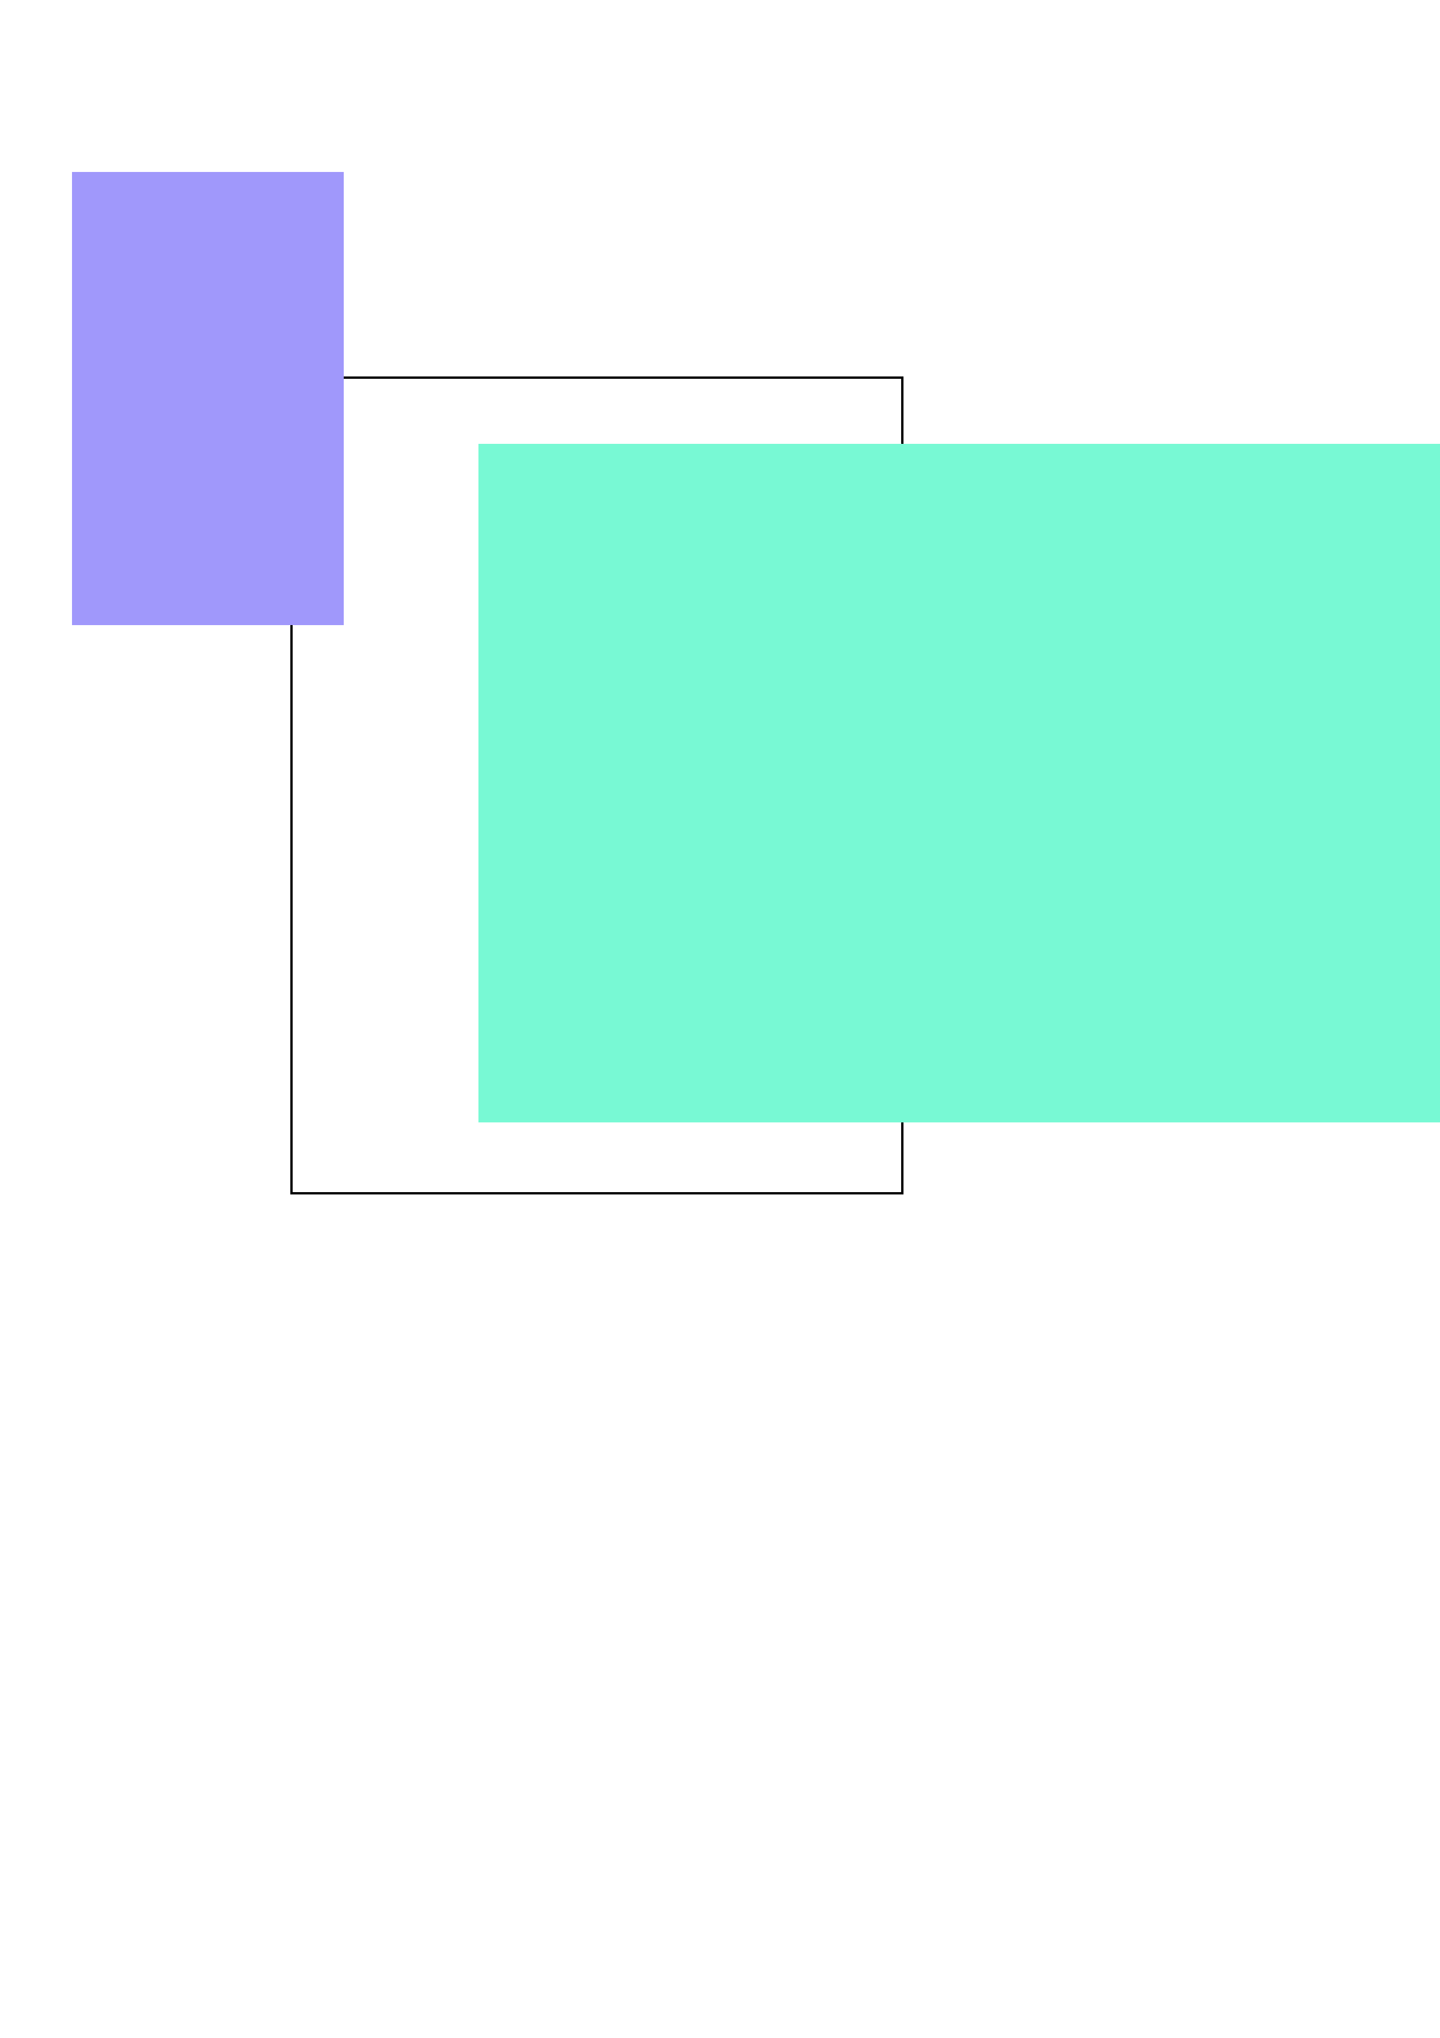

**T Level Technical Qualification in Health**

V4.2

P001988

9 May 2023 – 19 May 2023

603/7066/X

T Level Technical Qualification in Health

Employer set project (ESP)

Core skills

Pro-formas

Contents

Pro-forma: task 2(a): tutor feedback form 3

Pro-forma: task 2(b): healthcare plan template 6

Pro-forma: task 3(a): provide peer discussion feedback 8

Pro-forma: task 3(a): reflect on peer discussion feedback 10

Pro-forma: task 4: reflective account 11

Document information 14

# Pro-forma: task 2(a): tutor feedback form

The following form is for use in task 2(a).

Note:The spaces provided below are **not** indicative of length of response required

##### Person-centred care

|  |  |  |  |
| --- | --- | --- | --- |
| **Appropriate questions were asked to inform the care approach and explore options** | | | |
| 1 Entirely disagree | 2 Mostly disagree | 3 Mostly agree | 4 Entirely agree |

|  |  |  |  |
| --- | --- | --- | --- |
| **The care goals for the chosen individual were established** | | | |
| 1 Entirely disagree | 2 Mostly disagree | 3 Mostly agree | 4 Entirely agree |

|  |  |  |  |
| --- | --- | --- | --- |
| **The approach was safe, compassionate and respectful** | | | |
| 1 Entirely disagree | 2 Mostly disagree | 3 Mostly agree | 4 Entirely agree |

|  |
| --- |
| **Other feedback** |
|  |

##### Communication

|  |  |  |  |
| --- | --- | --- | --- |
| **The communication was clear and effective with the chosen individual** | | | |
| 1 Entirely disagree | 2 Mostly disagree | 3 Mostly agree | 4 Entirely agree |

|  |  |  |  |
| --- | --- | --- | --- |
| **There was evidence of appropriate techniques to overcome communication barriers** | | | |
| 1 Entirely disagree | 2 Mostly disagree | 3 Mostly agree | 4 Entirely agree |

|  |  |  |  |
| --- | --- | --- | --- |
| **Non-verbal communication was appropriate and effective** | | | |
| 1 Entirely disagree | 2 Mostly disagree | 3 Mostly agree | 4 Entirely agree |

|  |
| --- |
| **Other feedback** |
| **sdfahiksfhnikwfoiewfg** |

The tutor must sign this piece of work for the purposes of validation

|  |  |
| --- | --- |
| **Student number** | **Provider number** |
|  |  |
| **Student name** | **Tutor name** |
|  |  |
| **Student signature** | **Tutor signature** |
|  |  |

# Pro-forma: task 2(b): healthcare plan template

The following template is for use in task 2(b).

Note:The spaces provided below are **not** indicative of length of response required. However, you should consider how you will approach this task with your response

|  |  |  |
| --- | --- | --- |
| Patient name | Healthcare worker name and job title | Date completed |
|  |  |  |

|  |
| --- |
| Individual’s goals |
|  |

|  |
| --- |
| Individual’s choices and needs |
|  |

|  |
| --- |
| Individual’s values |
|  |
| Any other information |
|  |

|  |  |  |  |
| --- | --- | --- | --- |
| Healthcare/support needs | Healthcare/support approach | People and teams involved in care/support | Any further recommendations and future actions |
|  |  |  |  |

# Pro-forma: task 3(a): provide peer discussion feedback

Copy this table to provide individual feedback for each student within your group.

|  |  |
| --- | --- |
| **Student name** |  |
| **Activity plan** |  |
| **Date** |  |

|  |
| --- |
| **State one aspect of the student’s healthcare plan that you thought would work well and why.** |
|  |
| **Prepare one question to ask about the student’s healthcare plan.**  **Your question should be about how and why they have written the plan the way it is.** |
|  |
| **Provide one example of how you feel the student’s healthcare plan could be improved.** |
|  |

The tutor must sign this piece of work for the purposes of validation

|  |  |
| --- | --- |
| **Student number** | **Provider number** |
|  |  |
| **Student name** | **Tutor name** |
|  |  |
| **Student signature** | **Tutor signature** |
|  |  |

# Pro-forma: task 3(a): reflect on peer discussion feedback

Print out this form to allow completion of handwritten notes of the peer discussion. Please ensure that your writing is legible and that the document is suitable for scanning so it can be made available as an electronic piece of evidence. If you wish to expand the space to cover multiple pages before printing, feel free to do so.

|  |
| --- |
| **Questions you were asked by your peers** |
|  |

|  |
| --- |
| **What your peers felt would work well in your healthcare plan and why** |
|  |

|  |
| --- |
| **Examples of how your peers think that your healthcare plan could be improved** |
|  |

# Pro-forma: task 4: reflective account

The spaces provided below are **not** indicative of length of response required. Consideration should be given to the time limit stated in the ‘conditions of the assessment’ section of the task.

You should consider the following areas when completing this task:

* how you feel you approached the overall project and how you achieved the tasks individually
* evaluate your performance and experience, reflecting on what did and did not go well and focusing on your strengths and weaknesses in both performance and knowledge
* outline conclusions you can draw from this experience
* identify areas you would approach differently or improve if you were to be faced with a similar project

|  |
| --- |
| **Overall approach to the project** |
| Strengths |
| Areas for development |

| **Performance on each task** |
| --- |
| Task 1 |
| Task 2(a) |
| Task 2(b) |
| Task 3(a) |
| Task 3(b) |
| Task 4 |

|  |
| --- |
| **Evaluation of how your overall project outcomes meet the brief** |
|  |
| **What are your areas for improvement, and what would you do differently in the future?** |
|  |

|  |
| --- |
| **Conclusions drawn from the project, and what else you could have done?** |
|  |

# Document information

All the material in this document is © NCFE.

‘T-LEVELS’ is a registered trade mark of the Department for Education.

‘T Level’ is a registered trade mark of the Institute for Apprenticeships and Technical Education.

‘Institute for Apprenticeships & Technical Education’ and logo are registered trade marks of the Institute for Apprenticeships and Technical Education.

Owner: Head of Assessment Design.