Digital Devices Prohibited

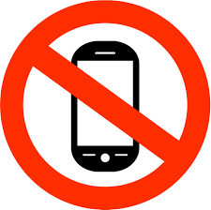

The following items are restricted from the examination room:

MOBILE PHONES
TABLETS
IPODs, MP3/4 PLAYERS
SMARTWATCHES

NO POTENTIAL TECHNOLOGICAL/WEB ENABLED SOURCES OF INFORMATION

Possession of unauthorised items, such as a mobile phone, is an infringement of NCFE Regulations for the Conduct of EPA and could result in DISQUALIFICATION from your end-point assessment

