
Endorsed Programmes Application Form

(New NCFE Customers)

NCFE uses Credit Safe to perform credit checks on new customer applications which are not public sector organisations for the purposes of deciding whether to offer credit, and also to prevent fraud, money laundering and any other unlawful activity. We reserve the right to request that a blended credit check be undertaken using these details. A blended check allows us to gain insight into the wider business interests and track records of the people behind the company, as well as the company’s data. This credit check against individuals may subsequently show on an individual’s credit history. From this check and where appropriate, NCFE may refuse credit and/or custom without further explanation.

Purchase Order number

We require a Purchase Order from you for your initial application fee. This will be detailed on your invoice summary report and sent electronically to the finance contact provided on this application form. Please refer to our fees and pricing document.

Please enter all details clearly handwritten or in typeface. We’ll return your application form if it’s incomplete or completed incorrectly.
Please send the completed application form to the Accreditation and Employer Services team at the following address:

NCFE Q6 Quorum Business Park
Benton Lane
Newcastle upon Tyne
NE12 8BT

Tel No: 0191 239 8000
Email: Customersupport@ncfe.org.uk
Should you require any further assistance or clarification for the purpose of completing this application form, please contact the Customer Support team on 0191 239 8000 or e-mail customersupport@ncfe.org.uk

Before you apply

In order to offer Endorsed Programmes please ensure you have the following policies in place, we may ask for evidence of these policies during our annual quality monitoring audit:

• equality and diversity
• safeguarding
• complaints procedure
• health and safety.

Before you complete your approval form please answer the following questions:

1. Are you an Approved Centre for any other recognised awarding organisation? | (Select as appropriate)  Yes ☐ No ☐  If yes, please name at least one recognised awarding organisation and give your Centre Number and attach your evidence | Click or tap here to enter text.
2. Have you ever been refused approval by a recognised awarding organisation?  (if you answer yes it won’t necessarily prevent you from gaining approval) | (Select as appropriate)  Yes ☐ No ☐  If yes, please state:  • name of recognised awarding organisation  • reason for refusal  • date of refusal | Click or tap here to enter text.
3. Have you ever had your approval withdrawn by a recognised awarding organisation?  (if you answer yes it won’t necessarily prevent you from gaining approval) | (Select as appropriate)  Yes ☐ No ☐  If yes, please state:  • name of recognised awarding organisation  • reason for withdrawal  • date of withdrawal | Click or tap here to enter text.
4. Do you currently have any sanctions applied upon you by any recognised awarding organisations?  (if you answer yes it won’t necessarily prevent you from gaining approval) | (Select as appropriate)  Yes ☐ No ☐  If yes, please state:  • name of recognised awarding organisation  • reason for sanction  • date of sanction | Click or tap here to enter text.
5. Have you or any of your directors worked with an approved NCFE centre which has gone into liquidation? | Select as appropriate)  Yes ☐ No ☐  If yes, please give details of the centre. | Click or tap here to enter text.

1 A recognised Awarding Organisation is one which complies with the criteria of the recognition process of the regulatory authorities which include the Office of Qualifications and Examinations Regulation (Ofqual), Qualifications Wales (QW) and CCEA Regulation in Northern Ireland. You can check a list of recognised Awarding Organisations at Ofquals website.

Section 1:
Company details

National Company Number:  (if applicable) | Click or tap here to enter text.
Registered Company Number: | Click or tap here to enter text.
Company name: | Click or tap here to enter text.
Main address: | Click or tap here to enter text.
Invoice address:  (if different from the one provided above) | Click or tap here to enter text.

Telephone number: | Web address:
Click or tap here to enter text. | Click or tap here to enter text.

Company type: (select the appropriate option)

FE – General | ☐ | Hospital/Health Service | ☐ | Local Authority – Adult Education | ☐
FE – Agriculture Horticulture | ☐ | Voluntary Organisational/Charity | ☐ | Local Authority – Licensing | ☐
FE – Art, Design & Performing Arts | ☐ | School | ☐ | Local Authority – Training Dept | ☐
FE – Specialist | ☐ | Special Needs School/ College | ☐ | Local Authority – Other | ☐
Independent School/College | ☐ | Higher Education Institution | ☐ | Adult/Community Provider | ☐
Prison | ☐ | Private Training Provider | ☐ | Employer | ☐
Sixth Form College | ☐ | Other (please specify) Click or tap here to enter text.

Principle or Head of Company
Title: Click or tap here to enter text. | First name: Click or tap here to enter text. | Surname: Click or tap here to enter text. | Job role: Click or tap here to enter text.
Contact email:  Click or tap here to enter text. | Direct line:  Click or tap here to enter text. | Site based at:  Click or tap here to enter text.

Finance Officer
Title: Click or tap here to enter text. | First name: Click or tap here to enter text. | Surname: Click or tap here to enter text. | Job role: Click or tap here to enter text.
Contact email:  Click or tap here to enter text. | Direct line:  Click or tap here to enter text. | Site based at:  Click or tap here to enter text.

Details of satellite sites
A satellite is a site which is part of your company but operates from a different address to your main company address. The main site is responsible for the quality assurance of any satellite sites.

If you intend to deliver the Endorsed Programme you are applying for in satellite sites, please provide details of the satellite sites below:

National Centre Number:  (if applicable) | Click or tap here to enter text.
NCFE Centre Number:  (if already an NCFE approved centre) | Click or tap here to enter text.
Site name: | Click or tap here to enter text.
Main address: | Click or tap here to enter text.
Telephone number: | Click or tap here to enter text.

If you will be delivering your Endorsed Programme via a sub-contract arrangement or advertising it through any third parties we need to know the details for these partners. Please complete the table below with as much detail as possible.

*Please note: as the lead customer for Endorsed Programmes it is your responsibility to ensure all third parties adhere to our advertising stipulations for Endorsed Programmes.

Third party company name | Click or tap here to enter text.
Contact name | Click or tap here to enter text.
Contact details | Click or tap here to enter text.
Nature of relationship | Click or tap here to enter text.
Links to online presence | Click or tap here to enter text.

Section 2:
Details of the Endorsed Programme

Programme title
Click or tap here to enter text.

Endorsed Programme contact details:
This would be the best person to contact about your Endorsed Programme.

Title: | Click or tap here to enter text.
Name: | Click or tap here to enter text.
Job title: | Click or tap here to enter text.
Email: | Click or tap here to enter text.
Direct line: | Click or tap here to enter text.

Please mark which brand you’d like your Endorsed Programme to be approved under.
NCFE | ☐
CACHE | ☐

*Please note: any programmes under the CACHE brand would have to be within the context of health and social care or early years education.

Endorsed Programme type (please place an ‘X’ in the most appropriate box):
Seminar | ☐ | Presentation | ☐
Workshop | ☐ | CPD | ☐
Materials | ☐ | Framework | ☐
Standards | ☐ | Platform | ☐

Other: (please specify)

Click or tap here to enter text.

Description of programme:
Click or tap here to enter text.

Please send a copy of your programme to us along with this application, or provide login details where appropriate.

What is the rationale?  (reason(s) for developing the Endorsed Programme) | Click or tap here to enter text.
Please give us a brief description of the aims and objectives of the programme | Click or tap here to enter text.
What are the methods of delivery? | Click or tap here to enter text.
What is the target group?  (Information on the learners that the programme is designed for) | Click or tap here to enter text.
Please describe the ongoing programme monitoring and review activities that will be applied | Click or tap here to enter text.
What is the target date for the programme to start? | Click or tap here to enter text.
Please provide information on how you have considered and embedded ED&I into this programme where possible | Click or tap here to enter text.
What is the forecasted number of learners expected to take part? | Click or tap here to enter text.

Materially different

When we review your Endorsed Programme we’ll look at your reasons for developing it, including why our existing NCFE regulated qualifications don’t meet your needs and we will also check if your programme is materially different to any of NCFE’s regulated qualifications. The purpose of the materially different check is for us to be sure that your programme is not similar to one of our regulated qualifications. This helps to ensure that learners would not consider this as an NCFE owned and regulated qualification.

We would require that you would check that it is not similar to any other regulated qualification. If you need any advice on this, please do not hesitate to get in touch.

Please explain how your programme is materially different

Click or tap here to enter text.

Section 3:
Company declaration

Please read the stipulations for advertising and promoting Endorsed Programmes before accepting this declaration, which can be found here.

I accept that NCFE will undertake a blended credit check of the company (where applicable) before progressing this application.
I can confirm that the content of this programme is original and doesn’t infringe on any third party’s copyright or Intellectual Property Rights. NCFE can in no way be held responsible for infringements of this kind.
I confirm that the delivery staff are occupationally competent in the subject area
I confirm that the company will let NCFE know of any changes to the information within this declaration within 2 weeks of the change(s) taking place.
I confirm that the company will collect all personal data in accordance with Data Protection Legislation, and in particular that it has the consent of the learner for their information to be shared with NCFE.
I accept that NCFE will hold and process electronically the information given and may use it for any purpose deemed relevant to the Endorsed Programme.
I confirm that the company will not advertise and promote provision as endorsed by us until the company has received written confirmation from NCFE that endorsement has been awarded for the Endorsed Programme.
I confirm that the company won’t advertise or promote the NCFE Endorsed Programme service in a manner that’s likely to be misleading to learners or other users.
I confirm that the company’s Senior Management Team supports this application to offer the Endorsed Programme as set out in this application.
Regulators’ Condition of Recognition B5 Declaration
1. I confirm that we understand that this programme is considered, by the qualification Regulators* and NCFE, to be unregulated provision and as such we will not make any verbal or written statement that would be likely to lead learners to believe that this programme is a regulated qualification when it is not a regulated qualification.
2. I confirm that we will not advertise or promote this programme in a manner that is likely to be misleading to learners or other users**.
3. I can confirm I understand the term ‘materially different’ and I can confirm that my programme is materially different to that of any regulated qualification that is owned by NCFE
*The qualification Regulators are the Office of the Qualifications and Examinations Regulator (Ofqual) in England, Qualifications Wales (QW) and the CCEA Regulation in Northern Ireland.
**Other users could include any organisation, professional body or learners’ representatives who may review the programme on your website or in your publications.

Signed  (appropriate senior personnel) | Click or tap here to enter text. | Job title: Click or tap here to enter text.
Full name:  (please print) | Click or tap here to enter text. | Date: Click or tap here to enter text.

Section 4:
We love to hear your feedback

How did you find out about NCFE’s Endorsed Programme Service? (please tick all that apply)

Own knowledge and experience of NCFE |  | ☐ | NCFE sales events | ☐
Referral from colleague in another company |  | ☐ | Trade press | ☐
Referral from colleague in own company |  | ☐ | NCFE Business Development Team | ☐
NCFE literature |  | ☐ | Other NCFE staff | ☐
Press article/advert |  | ☐ | NCFE website | ☐
NCFE newsletter/emails |  | ☐ | Exhibition/Conference | ☐
Social networking sites |  | ☐ | Other (please specify): | ☐

What were your main reason/s for choosing to work with NCFE to endorse your programme? (please tick all that apply)

Price | ☐ | Switching from another Awarding Organisation | ☐
Flexibility | ☐ | Service | ☐
Other (please specify): Click or tap here to enter text.

Digital badges application template

Title of programme
Please add the same title of the programme we have endorsed.

Programme overview
Please provide a high-level overview of the learning that has been completed.
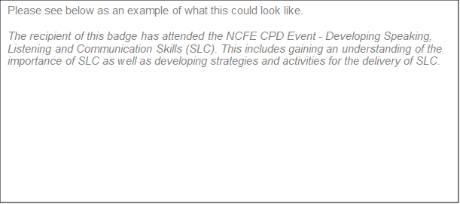

Issuer
Please input the name of your centre
Tags
Please provide any hashtags that you feel are relevant to this digital badge

Hyperlink
If you would like to embed a link in your digital badge, please add this here.

Criteria
Please provide an overview of what the learner has to do in order to receive the digital badge
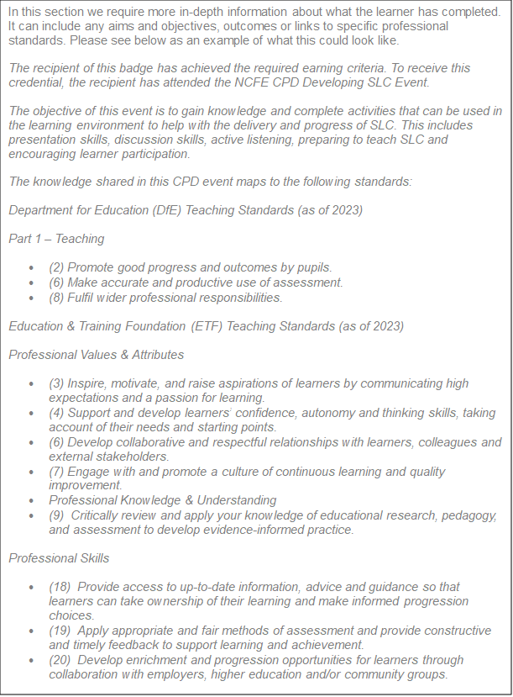

Digital badges branding

To add your branding onto any digital badges you issue, you will need to provide a PNG or JPEG file of your organisation’s logo, ideally with a transparent background.

