Name
Tutor/Department
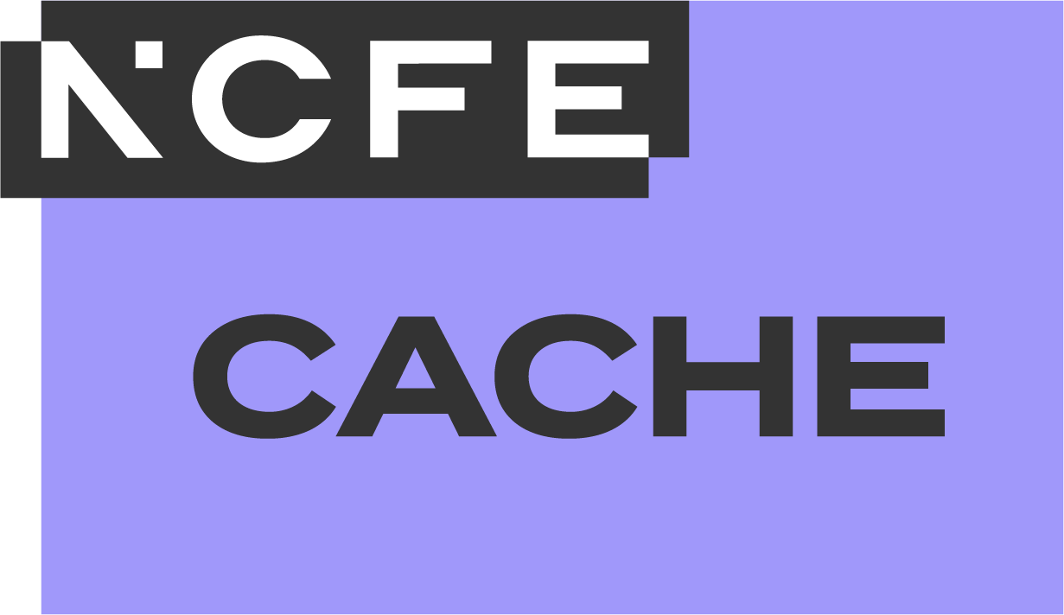
NCFE CACHE Level 3 Extended Diploma for Working in the Early Years Sector (Early Years Educator) (610/6133/5)


Learner Guide
Units 11 to 16
Copyright notice
© NCFE 2025 All rights reserved. No part of this document may be reproduced, distributed, or transmitted in any forms or by any means, including photocopying, recording, or other electronic or mechanical methods, without the prior written permission of NCFE.
NCFE resources available in a digital format can be adapted to learners’ needs but trademarks, copyright or other proprietary notices cannot be deleted or modified without permission.
The content of this document is, unless otherwise indicated, the intellectual property of NCFE. Users are permitted to view, print, and download the material for personal, non-commercial and classroom use (for example, non-commercial use by a qualified educational institution) only. Users are not permitted to remove or amend trademarks, copyright, or other proprietary notices.
Version | Publication year
1.0 | 2025
Disclaimer
NCFE resources are optional support tools and are not essential to the delivery of the relevant qualification. They provide an interpretation of how the subject content listed in the Qualification Specification can be delivered. They are written and reviewed by subject experts independently to the Qualification Specification and to the assessment materials. The content included in these resources does not indicate any content coverage in summative assessment materials.
Centres must refer to the Qualification Specification for the relevant qualification for full details of the mandatory content of the qualification. The teaching guidance section of the Qualification Specification is advisory and provides useful guidance to support delivery of the teaching content of the qualification.
The content of these resources is correct at the time of publishing but may be subject to change.

Contents
Contents 3
Introduction 4
Unit 11 5
Reflection and supervision in an early years setting 5
Unit 12 13
Learner-led enquiry in an early years setting 13
Unit 13 19
Sustainable practice in an early years setting 19
Unit 14 26
Neuroscience for early years practice 26
Unit 15 32
Understand the role of the early years educator as an advocate for children with special educational needs and disabilities (SEND) 32
Unit 16 38
Enabling play environments in an early years setting 38
Workplace diary 47
Feedback and reflection 51
Contact us 55

Introduction
This learner guide is designed to support the knowledge, skills and behaviours required of a level 3 early years educator when employed and included in staff to child ratios in an early years setting. This learner guide is for use with units 11 to 16 of the Level 3 Extended Diploma for Working in the Early Years Sector. Units 1 to 10 can be found in a separate learner guide which links to this qualification as well as the Level 3 Diploma for Working in the Early Years Sector and the Level 3 Technical Occupational Entry for the Early Years Workforce (Diploma).
These tasks offer additional learning support, providing opportunities to gain knowledge that can be applied to work in an early years setting. Providers are invited to utilise any of these tasks according to learning context, needs of the learner and job roles, to complement teaching and learning in preparation for formal assessment or consolidation of knowledge to check understanding.

Towards the end of the learner guide, there is a workplace diary; this can be used to help recognise new skills as well as areas for improvement following each week or work placement session. Also included are feedback and reflection sheets to help further develop knowledge and skills following any groupwork such as presentations, peer feedback and tutor and assessor feedback.
Please note: to avoid any conflict of interest, learning resources are developed without insight into assessment materials. This resource contains no summative assessment.

Unit 11

Reflection and supervision in an early years setting



Unit 11 learning objectives
LO1 | Understand the role of reflection for improved outcomes in an early years setting.
LO2 | Understand theoretical models for reflection.
LO3 | Understand the requirements for supervision in line with early years foundation stage (EYFS) statutory framework requirements for early years.
LO4 | Be able to reflect upon own practice in an early years setting.
LO5 | Participate in a supervision meeting in an early years setting.


Activity 1: benefits of reflection
Create a mind map to identify the benefits of reflection for improved outcomes in an early years setting.
You should consider:
- the early years educator
- the babies and young children
- colleagues
- the early years setting
How can reflection prepare an early years educator for supervision meetings in an early years setting?


Activity 2: theoretical models for reflection
Research the following theoretical models for reflection and summarise your findings.
You should consider:
- key points of each
- benefits the theoretical models provide
- similarities and differences between the theoretical models
Boud, Keogh and Walker
Gibbs
Kolb

Activity 3: requirements for supervision
List the requirements for supervision in the early years in line with statutory frameworks.
You should consider the Early Years Foundation Stage (EYFS) statutory framework for group and school-based providers.
Assess supervision within your own setting against the requirements of the EYFS.


Activity 4: application of theoretical model
Choose one of the theoretical models for reflection and apply its stages to prepare for a supervision meeting. Make preparation notes below.
You should consider theories from:
- Boud, Keogh and Walker
- Gibbs
- Kolb


Activity 5: setting SMART targets
Read the guidance below and use the space provided to set your own SMART targets. Think about your supervision meetings and use these to create and shape your priority areas.
S | Specific
M | Measurable
A | Achievable
R | Relevant
T | Time-bound
Specific: targets should be clear and specific. When choosing a target, think about what you want to accomplish; why the target is important; who is involved; where it is located; what resources you need.
Measurable: targets must be measurable in some way, so that you can track your progress and stay motivated. A measurable target should address questions such as: how will I know when it is accomplished?
Achievable: targets need to be realistic and attainable – it should stretch your abilities but still remain possible. This does not mean that you have to give up on a target, but it may mean breaking it down into more achievable chunks.
Relevant: targets should matter to you. A target should be something that you have control over. One way to check if a target is relevant is if you can answer ‘yes’ to these questions:
- Is this target worthwhile?
- Is this the right time?
- Is it achievable in the current socio-economic environment?
Time-bound: targets need a target date so that you have a deadline to focus on and something to work towards. The target date does not need to be a specific day, but it should be as specific as you can make it. A time-bound target will usually answer these questions:
- What can I do now?
- What do I want to be able to do six weeks from now?
- What do I want to be able to do six months from now?

Unit 12

Learner-led enquiry in an early years setting


Unit 12 learning objectives
LO1 | Understand the role of evaluation and reflection to initiate change in an early years setting.
LO2 | Understand collaboration with colleagues for effective change management.
LO3 | Understand stages in a learner-led enquiry.
LO4 | Be able to collaborate with colleagues to develop an informed rationale for change.
LO5 | Be able to plan a process for change in the early years setting.
LO6 | Be able to reflect upon a plan for change.

Activity 1: theoretical models supporting change
Research the following theories for supporting change in an early years setting and summarise your findings.
You should consider:
- key points of each
- how they relate to an early years setting
Change Curve
(Kübler-Ross)
Three-Stage Model of Change
(Kurt Lewin)

Activity 2: rationale for change
Why is it important to have an evidence-based rationale for change in an early years setting?
You should consider the impact change could have on:
- the babies and young children
- the early years educator
- other colleagues
- the early years setting
- other professionals

Activity 3: action plan for change
Create an action plan to support a change in an early years setting.
You should consider the following questions.
- What is the rationale for this change?
- What outcome or outcomes is this change hoping to achieve?
- What are the key milestones within this change process?
- What challenges might occur during this change and how could they be overcome?


Activity 4: benefits and complexities of collaboration
List some of the benefits and complexities of collaborating with colleagues for effective change management in an early years setting.
Benefits | Complexities


Activity 5: problem solving
Choose one of the complexities from activity 4 – what could you do to overcome this in an early years setting?
Complexity of collaboration with colleagues:
Possible solutions:

Unit 13

Sustainable practice in an early years setting


Unit 13 learning objectives
LO1 | Understand sustainable practice in an early setting.
LO2 | Know about the purpose of the Sustainable Development Goals (SDGs).
LO3 | Understand governmental policy for sustainable practice.
LO4 | Be able to model sustainable practice in the early years setting.
LO5 | Be able to reflect on sustainable practice in the early years setting.
LO6 | Be able to develop a policy statement for sustainable practice in the early years setting.

Activity 1: sustainable practice in early years
List the current 17 Sustainable Development Goals (SDGs) created by the United Nations.
1 |  | 10
2 |  | 11
3 |  | 12
4 |  | 13
5 |  | 14
6 |  | 15
7 |  | 16
8 |  | 17
9
How important are these goals in the context of early years practice? How do they relate to sustainable practice in an early years setting?

Activity 2: sustainability ambitions
Research and summarise the ambitions of the UK government for sustainable practice.
How do these ambitions relate to an early years setting? Summarise your findings below.

Activity 3: modelling sustainable practice
Consider how sustainable practice can be modelled in an early years setting. Create a mind map to reflect your thinking.
You should consider the role and impact of:
- an early years educator
- parents and carers
- colleagues
- the early years setting
- other professionals
- available resources

Activity 4: evaluating sustainable practice
Identify sustainable practice in your early years setting and answer the questions below.
- What is going well?
- What can be improved?
- Does your setting have any specific challenges?
- How could your setting overcome any challenges or make improvements?

Activity 5: action plan for sustainable practices
Create an action plan to enhance the sustainable practices in an early years setting.
You should consider the following questions.
- What recommendations for change do you suggest?
- What outcome or outcomes is this change hoping to achieve?
- What challenges might occur during this change and how could they be overcome?

Unit 14

Neuroscience for early years practice


Unit 14 learning objectives
LO1 | Know about early brain development.
LO2 | Understand how the human brain responds to adverse conditions.
LO3 | Understand the role of the early years educator to provide a responsive, nurturing environment for babies and children and their families.
LO4 | Be able to share information about early brain development with parents and carers.


Activity 1: brain development
Outline the stages of brain development during pregnancy to seven years.
Stage | Brain development
Pregnancy
Birth to 12 months
Early infancy
1 year to 5 years
5 to 7 years

Activity 2: purpose and function
Research and summarise the purpose and function of the following terms in the context of early brain development:
- neurons
- synaptogenesis
- synaptic pruning
Term | Purpose | Function
neurons
synaptogenesis
synaptic pruning
What is their connection to future holistic learning?

Activity 3: responses to adverse conditions
Research the following and complete the tables below.
Part 1: what is the impact of stress and trauma on the function of the human brain?
You should consider different categories of:
- stress, for example, positive, tolerable and toxic
- trauma, for example, fight, flight, freeze and fawn
Stress | Trauma
Part 2: what is the impact of stress and trauma in the short and long term for an individual’s holistic health and wellbeing?
Short-term holistic health and wellbeing | Long-term holistic health and wellbeing
Stress: | Stress:
Trauma: | Trauma:

Activity 4: responsive and nurturing environment
Create a mind map to identify the role of the early years educator in providing a responsive, nurturing environment for babies, children and their families.
You should consider:
- the role of co-regulation in an early years setting
- strategies for self-regulation to support babies’ and children’s emotional wellbeing
- the impact of engaging professional relationships with parents and carers for babies’ and children’s emotional wellbeing

Unit 15

Understand the role of the early years educator as an advocate for children with special educational needs and disabilities (SEND)


Unit 15 learning objectives
LO1 | Understand the legislative framework in place to support children with special educational needs and disabilities (SEND).
LO2 | Understand the importance of working in partnership with parents and carers to effectively meet the needs of children with SEND.
LO3 | Understand the role of early intervention for children with SEND in an early years setting.

Activity 1: legislative requirements
List the legislative frameworks that underpin SEND provision in an early years setting.
Identify how SEND policies reflect legislative requirements for early years practice.

Activity 2: importance of working in partnership
List the benefits and complexities of working in partnership with parents and carers to effectively meet the needs of children with SEND in an early years setting.
Benefits | Complexities

Activity 3: problem solving
Choose one of the complexities from activity 2 – what could you do to overcome this in an early years setting?
Complexity of working in partnership with parents and carers to effectively meet the needs of children with SEND:
Possible solutions:

Activity 4: early intervention
Describe each stage of the process involved in early intervention for children with SEND in an early years setting. Explain why each stage is important.

Activity 5: early years educator as an advocate
Create a mind map to explore the role of an early years educator as an advocate for children with SEND and their families. Include details of why it is important to be an advocate.

Unit 16

Enabling play environments in an early years setting


Unit 16 learning objectives
LO1 | Understand influences on enabling play environments in an early years setting.
LO2 | Know about the Playwork Principles and the Play Cycle for children’s development, learning and wellbeing.
LO3 | Be able to provide an inclusive play-rich environment in the early years setting.
LO4 | Be able to explain the value of play with parents and carers.
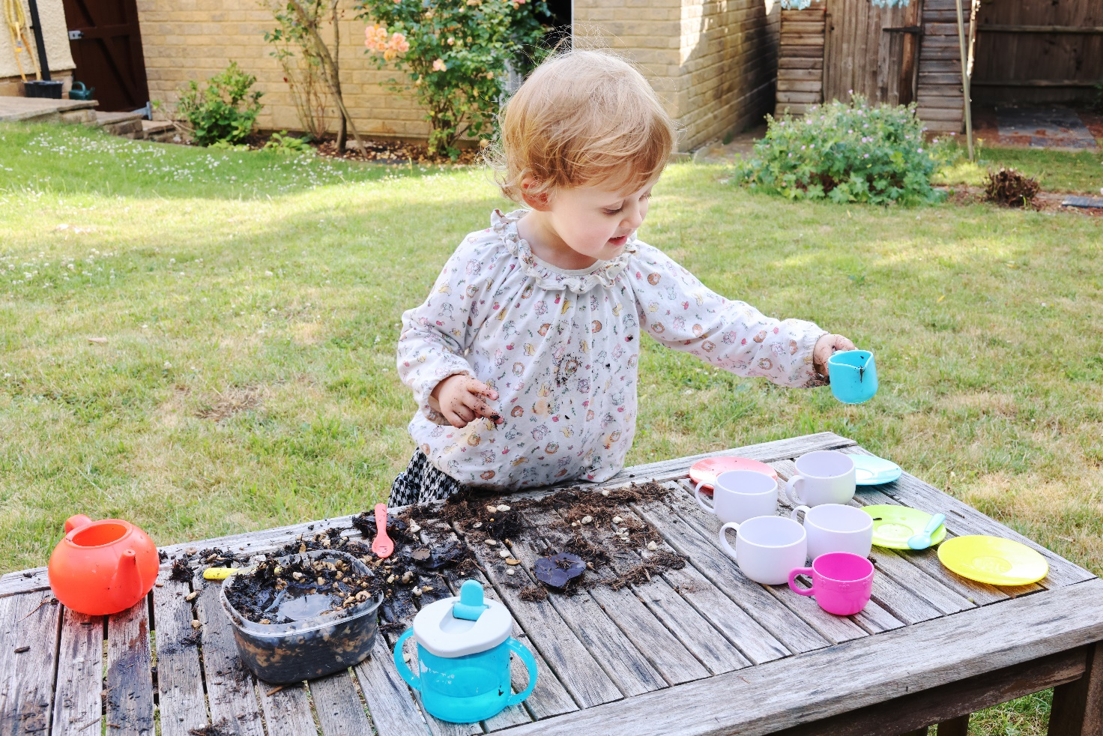
Activity 1: influences on enabling play environments
Research and summarise the influences on enabling play environments in an early years setting.
You should consider:
- statutory frameworks
- non-statutory guidance
- the characteristics of effective teaching and learning


Activity 2: effective teaching and learning
Reflect on an activity in your early years setting and describe how the characteristics of effective teaching and learning are embedded in the activity. If you think any characteristics are missing, how could you find a way to incorporate them?

Activity 3: Playwork Principles
Research and summarise the Playwork Principles. Make notes on how they can be used in an early years setting.

Activity 4: compound flexibility
Research Fraser Brown’s theory of compound flexibility and summarise your findings.
You should consider:
- key points
- how effective it is for increasing children’s resilience
- how it relates to an early years setting

Activity 5: Play Cycle
Research and summarise the stages of the Play Cycle. Include examples of how an early years setting could support play provision at each stage.
Stage | Summary and examples

Activity 6: play-rich environments
Reflect on the impact of factors that must be considered when planning an enabling play environment in an early years setting.
You should consider:
- individual needs of each baby or child
- preferences of each baby or child
- personal circumstances of each baby or child
Describe how reflective practice in an early years setting can contribute to an inclusive play-rich environment.

Activity 7: value of play
Create a mind map to identify the value of play for babies and young children in an early years setting.
You should consider:
- the impact of statutory frameworks
- the impact of non-statutory guidance
- the Playwork Principles
- play for holistic development and wellbeing
- compound flexibility
- the stages of the Play Cycle
- the benefits of a play-rich environment

Workplace diary



Workplace diary
Use this diary to record the hours completed, reflect on what you have learnt, detail your successes and achievements and anything you would do differently next time.
Activity:
Date/time/hours: | Tutor signature:
Reflective notes:
Activity:
Date/time/hours: | Tutor signature:
Reflective notes:
Activity:
Date/time/hours: | Tutor signature:
Reflective notes:

Workplace diary
Use this diary to record the hours completed, reflect on what you have learnt, detail your successes and achievements and anything you would do differently next time.
Activity:
Date/time/hours: | Tutor signature:
Reflective notes:
Activity:
Date/time/hours: | Tutor signature:
Reflective notes:
Activity:
Date/time/hours: | Tutor signature:
Reflective notes:

Workplace diary
Use this diary to record the hours completed, reflect on what you have learnt, detail your successes and achievements and anything you would do differently next time.
Activity:
Date/time/hours: | Tutor signature:
Reflective notes:
Activity:
Date/time/hours: | Tutor signature:
Reflective notes:
Activity:
Date/time/hours: | Tutor signature:
Reflective notes:

Feedback and reflection



Feedback and reflection
Feedback is an excellent way to develop your skills and learn new ones. Obtain feedback from a colleague, a fellow learner or a tutor.
Reflect on your learning experience. Consider:
- what went well
- what did not go so well

Feedback and reflection
Feedback is an excellent way to develop your skills and learn new ones. Obtain feedback from a colleague, a fellow learner or a tutor.
Reflect on your learning experience. Consider:
- what went well
- what did not go so well

Feedback and reflection
Feedback is an excellent way to develop your skills and learn new ones. Obtain feedback from a colleague, a fellow learner or a tutor.
Reflect on your learning experience. Consider:
- what went well
- what did not go so well

Contact us
NCFE
Q6
Quorum Park
Benton Lane
Newcastle upon Tyne
NE12 8BT
0191 239 8000*
www.ncfe.org.uk
*to continue to improve our levels of customer service, telephone calls may be recorded for training and quality purposes.
NCFE is a registered charity (Registered Charity No. 1034808) and a company limited by guarantee (Company No. 2896700).

