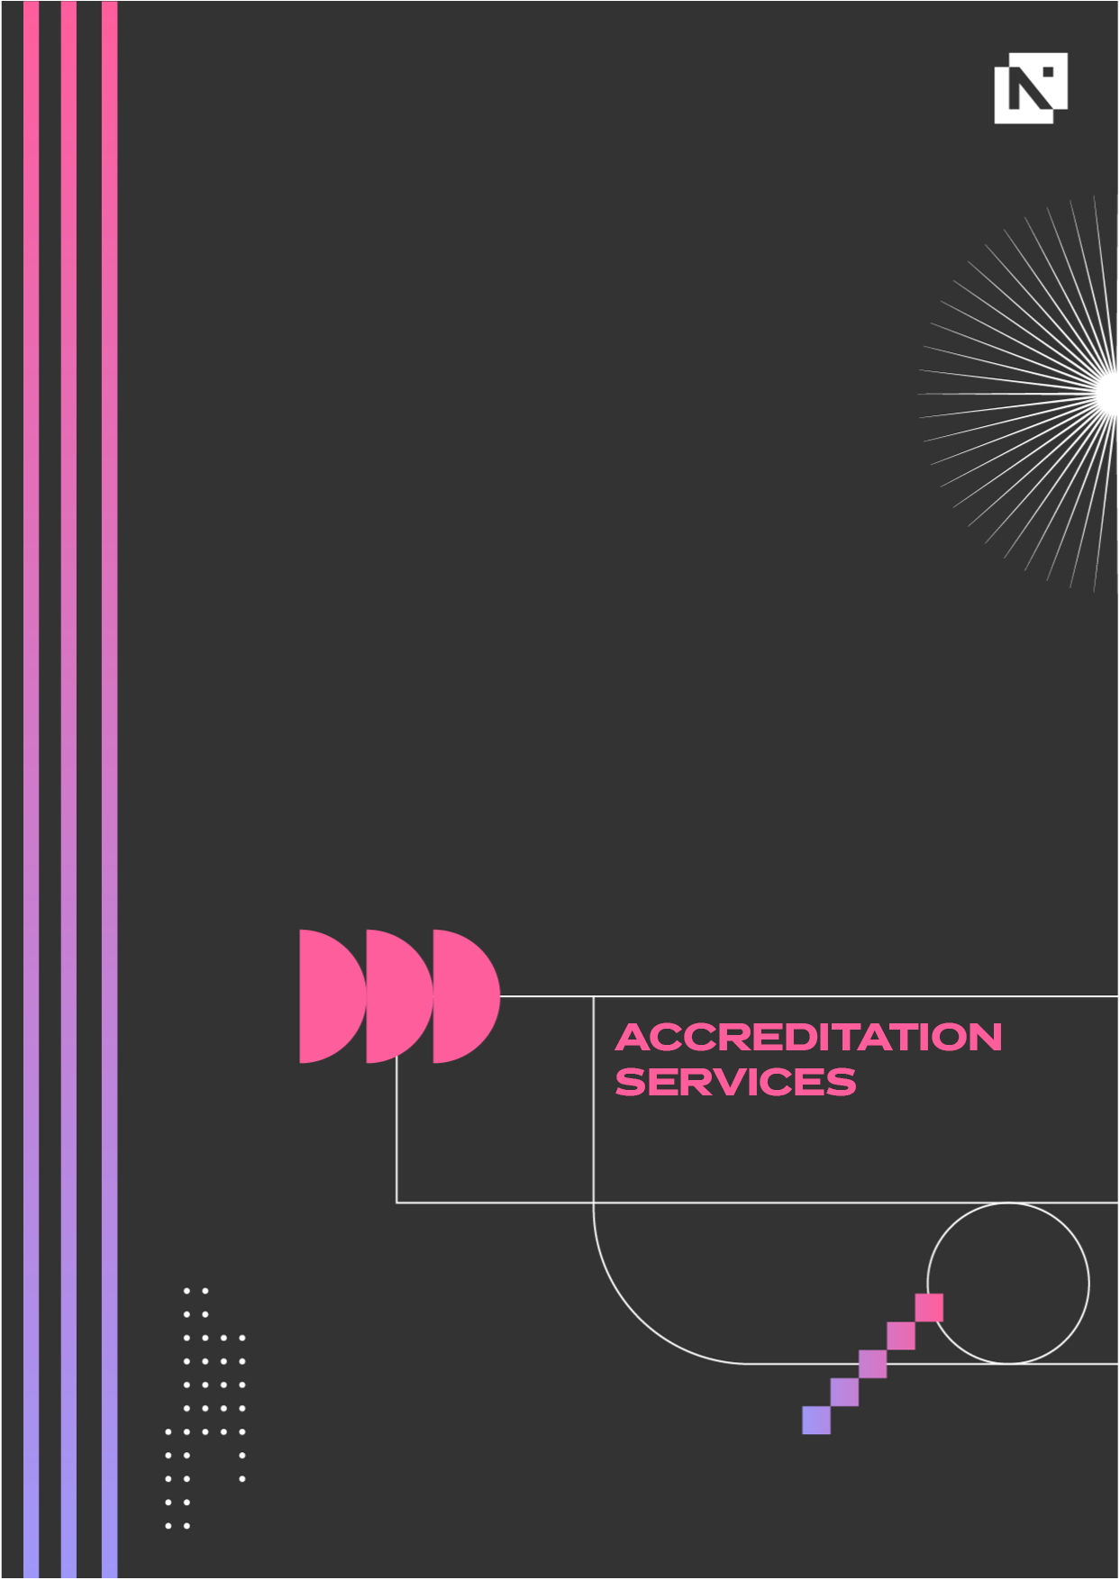
Stipulations
for advertising and promoting Endorsed Programmes
VERSION 1.2. | 01.01.2025

Contents

Section 1 2
Why do we need this document? 2
Section 2 3
How to advertise Endorsed Programmes 3
Section 3 4
Requirements 4
Section 4 5
Wording to clarify the nature of Endorsed Programmes 5
Section 5 6
Certification 6
Section 6 6
Advertising by satellite sites or sub-contractors 6
Section 7 7
Third party websites (group buying and discount voucher sites) 7
Section 8 7
Brand/logo 7

Section 1

Why do we need this document?

NCFE is a UK awarding organisation regulated by the qualification regulators1 and is subject to each of the qualification Regulators’ Conditions of Recognition. As such, we have a responsibility to ensure that all of our centres adhere to them. The Conditions of Recognition can be found on each qualification Regulators’ website.

Although the Conditions of Recognition relate to regulated qualifications (i.e. those on a national framework), there are two conditions which providers of unregulated products must adhere to. These are under Condition B5 - ‘Representations regarding qualifications’:

B5.1 - Statements regarding qualifications which are not regulated qualifications
An awarding organisation must not (and must take all reasonable steps to ensure that any person connected with it does not) make any statement that would be likely to lead Users of qualifications to believe that a qualification it makes available is a regulated qualification when it is not a regulated qualification. – Ofqual and CCEA

An awarding body must not (and must take all reasonable steps to ensure that any person connected with it does not) make any statement (via any act or omission) that would be likely to lead Users of qualifications to believe that a qualification it makes available (whether regulated or not) is an Approved, Designated or regulated qualification when it is not an Approved, Designated or regulated qualification - QW

B5.2 - Advertising and promotion of qualifications
An awarding organisation must not (and must take all reasonable steps to ensure that any person connected with it does not) advertise or promote its qualifications in a manner that is likely to be misleading to Users of qualifications.

The reason the conditions above are in place is to ensure that learners are not misled in any way into thinking that an Endorsed Programme is a nationally recognised regulated qualification owned by NCFE.

1 Ofqual in England (www.ofqual.gov.uk), Qualifications Wales in Wales (www.qualificationswales.org), and CCEA Regulation in Northern Ireland (www.ccea.org.uk/regulation).

Section 2

How to advertise Endorsed Programmes

When advertising Endorsed Programmes you can use wording that is appropriate to your centre, but must make it clear to learners and/or potential User that they are not nationally recognised qualifications regulated by qualification regulators.

To avoid misleading users that the product is a regulated qualification when it is not, we have provided wording that we strongly recommend you use when advertising or promoting Endorsed Programmes, please see section 4.

This wording will enable your learners to make an informed choice which best meets their needs. Learners will be able to compare it with regulated qualifications and discuss the relevancy of the programme content with the potential employer or organisation for further study.

The advertising on your website and promotional materials will be reviewed as part of your annual Quality Monitoring Audit, and will be monitored on an ongoing basis. Please make sure that all points are met.

Section 3

Requirements

What you must do:

• Use appropriate descriptions of each Endorsed Programme endorsed by us, clearly stating that it is an Endorsed Programme and is not nationally recognised in all documentation (including induction materials, website, promotional materials etc.) for learners and clients to advertise the product truthfully and not to mislead learners.
• Ensure that any advertising by third parties, satellite centres and sub-contractors is consistent with and also follows the stipulations outlined in this document. Please see sections 6 and 7.
• Use the same programme title that appears on your Endorsed Programme confirmation email when advertising, demonstrating your ownership of the product.

What you must not do:

• Give learners cause to believe that your Endorsed Programme is a nationally recognised and regulated qualification when it is not
• Make any claims that the Endorsed Programme is ‘nationally recognised’ or a ‘nationally recognised qualification’
• Include NCFE in the title of your Endorsed Programme or use NCFE or as a prefix
• Imply that the Endorsed Programme meets industry standards to qualify a learner for employment when it does not
• Mislead learners by claiming that completion of an Endorsed Programme will entitle them to use post-nominals (such as ‘Dip xxx’) after their name
• Compare Endorsed Programmes with qualifications such as GCSEs, NVQs, etc.
• Advertise any Endorsed Programmes until you receive confirmation of endorsement
• Use the NCFE Endorsed Programme logo until you have received a written confirmation of the programme’s confirmation of Endorsement
• Use the NCFE Endorsed Programme logo to promote a franchise package or franchise product
• Continue to use the NCFE Endorsed Programme logo after the Endorsed Programme has expired or closed
• Use the NCFE brand or Endorsed Programme logo in any way that could mislead or be deemed as mis-selling
• Permit franchisees to use the NCFE Endorsed Programme logo to promote their own business, for example on Facebook, Wowcher, Groupon etc
• Use the standard NCFE logo on an in-house certificate you have created
• Use the NCFE Endorsed Programme logo or standard NCFE logo if you are not an approved NCFE customer
• Use words like ‘practitioner’, ‘professional’ or similar in the title of your programme, or mislead the learner into thinking the programme will give them ‘licence to practice’ in any professional role
• Use wording on in-house certificates that implies the programme is in any way regulated or part of any other CACHE qualification other than Endorsed Programmes
• Mislead learners into thinking the certificate they have received was issued by CACHE - customers must be clear that the certificate has been produced and issued in-house
• Use words like ‘Achieved’ or ‘Passed’ on your in-house certificates.

Section 4

Wording to clarify the nature of Endorsed Programmes

We have created the wording below to use when advertising each of the Endorsed Programmes endorsed by us. We strongly recommend you use this wording. You can use your own wording, but it must abide by the requirements listed in the previous section.

To describe what endorsement is:
Endorsement is designed to give formal recognition to an organisation’s bespoke programmes designed to enable professional development. An Endorsed Programme is not recognised as a regulated qualification.

To describe the programme endorsement:
Our programme has been developed to meet the specific needs of our learners and has been endorsed by NCFE demonstrating the quality and rigor.

NCFE is an awarding organisation recognised by the qualification regulators for England (Ofqual, Wales (Qualification Wales) and Northern Ireland (CCEA Regulation). This is an unregulated programme and is not a nationally recognised qualification.

We also strongly recommend you add the following statements to any materials relating to your Endorsed Programme(s):

Disclaimer statement
NCFE has exercised reasonable care and skill in endorsing this programme, and makes no representation, express or implied, with regard to the continued accuracy of the information contained in this programme. NCFE does not accept any legal responsibility or liability for any errors or omissions from the programme or the consequences thereof.

Endorsement Statement
These programmes have been reviewed by a Subject Specialist and are endorsed by NCFE, they are not a regulated qualification.

Section 5

Certification

Customers issuing in-house certificates for Endorsed Programmes are free to design them in any way they wish to, but they must follow the below guidance:

• Can only use the Endorsed Programmes logos provided and not any other NCFE/CACHE logos or branding, once you have received written confirmation of endorsement.
• Can use their own logos and branding on the in-house certificates along with the Endorsed Programme logos.
• Must not mislead learners into thinking the certificate they have received was issued by NCFE or CACHE, customers must be clear to learners that the certificate has been produced and issued by the customer themselves.
• Must not use wording on their in-house certificates that imply the programme is in any way regulated or part of any other NCFE/CACHE qualification other than Endorsed Programmes.
• Must not use the term certificate of ‘achievement’, or attribute a level to the programme, but can use certificate of ‘attendance’, ‘completion’ or ‘participation’ or a similar alternative. Any alternatives must be cleared with the Accreditation and Employer Services team prior to use.

Digital badges
Customers issuing digital badges for Endorsed Programmes must follow the below guidance:
• Can have their own logos included in the Digital Badge, under the NCFE standard branded template, including the NCFE Endorsed Programmes logo.
• Must not use wording on their digital badges that imply the programme is in any way regulated or part of any other NCFE/CACHE qualification other than Endorsed Programmes.
• Must not use the term certificate of ‘achievement’, or attribute a level to the programme, but can use digital badge as a recognition of ‘attendance’, ‘completion’ or ‘participation’ or a similar alternative. Any alternatives must be cleared with the Accreditation and Employer Services team prior to use.
• All learners must be made aware that they will receive a digital badge upon completion of the Endorsed Programme, consent from learners must be obtained to share their details with NCFE and Accredible, in order to claim the digital badge.

Section 6

Advertising by satellite sites or sub-contractors

A satellite sites or sub-contractors may advertise and deliver Endorsed Programmes on your behalf, and therefore have contact directly with learners registered through you as an NCFE customer (they may be a ‘satellite site’ of yours).

You should keep accurate and up-to-date records of all satellite sites/sub-contractors who advertise your Endorsed Programmes and let us know of any changes.

A satellite site is a location that is part of your company but which is not your main site, office or campus and that remains under your control and jurisdiction. A sub-contractor is an organisation to whom you may sub-contract part of the delivery.

It is your responsibility to make us aware of any satellite sites you have or sub-contracting arrangements you have in place.

You are responsible for ensuring that any satellite sites or sub-contractors you work with adhere to these stipulations and ensure that learners receive the same information.

The customer must ensure that any satellite sites or sub-contractors follow the points below:
• Adhere to all aspects of these stipulations and the points in our contract applicable to them (through their relationship with you).
• State, when advertising each programme, which customer the Endorsed Programme belongs to and that they are selling or promoting the programme on behalf of that customer.
• Ensure that all learners are provided with details of the correct title of the Endorsed Programme, programme description and the customer who owns the programme.
• Ensure that learners are provided with contact information for the customer who owns the programme, so that they can contact them with any queries about the delivery or to make a complaint.
• Do not make any claim or imply that they are the customer who owns the programme. • Do not use any NCFE logos on their website or on any promotional materials.

Section 7

Third party websites (group buying and discount voucher sites)

Customers may use third party websites to sell or promote the Endorsed Programmes, including but not limited to, Groupon, Wowcher, Living Social and Facebook. However, under no circumstances must the NCFE Endorsed Programme logo or description, or any other NCFE logo or trademark be used on these types of websites to promote or sell any products. They cannot be described as NCFE endorsed or have a description of the endorsement in the advert.

However, the advert may include a link to your website which has details of your status as an NCFE customer and your endorsement.

Section 8

Brand/logo

Please see the NCFE branding guidelines for details on how to use the NCFE Endorsed Programmes logo, they can be found in the guide to Endorsed Programmes here: https://www.ncfe.org.uk/accreditation-and-employer-services/endorsed-programmes.

If you have any queries about anything set out in these stipulations, or need any further information, then please contact our customer support team on 0191 239 8000 or customersupport@ncfe.org.uk

