**Guidance on Preparing for Placement in Education Settings**

**Module 2**



Contents

**Hello and welcome back!** 3

Topic 6: Exploring legislation, policy and procedure 3

Activity 4

Considering health and safety procedures in school or college 4

Activity 5

Activity 7

Topic 7: The impact of Covid-19 on schools and colleges 8

Activity 9

What is PPE? 10

Resources 11

# \\citygate.local\data\ClusterGroups\Marketing Team\2019-20\3.0 Marketing Operations\3B - CACHE\Content\Placement docs\1768 - illustrations-01.png**Hello and welcome back!**

“Hopefully, you are starting to build up a plan about how you can prepare yourself for your placement. In this module we will be looking at legislation, policies and procedures, don’t give up! It’s a tough area but we will guide you through and it will be an area that you will be able to relate to your placement once you are there.”

## **Topic 6: Exploring legislation, policy and procedure**

When you begin your placement, it will be helpful if you have explored the legislation, policy and procedures relevant to you as a Teaching Assistant. In this section we will guide you to the legislation which you will need to read to help with your understanding of your responsibilities.

The Early Years Foundation Stage Statutory Framework: Section 3 3.1–3.3 inclusive, will help you with your understanding of the legislation relating to the early years. You won’t be expected to be familiar with this at first, but you will learn about statutory requirements in class and you will be able to see how the framework is put into practice in your setting. If you are interested in finding out a little more about the framework there is a link provided here:

<www.gov.uk/government/publications/early-years-foundation-stage-framework--2>

This framework is for all early years providers in England (from 3 April 2017): maintained schools; non-maintained schools; independent schools (including free schools and academies); all providers on the Early Years Register; and all providers registered with an early year’s childminder agency (CMA).

The EYFS explains that:

*“Children learn best when they are healthy, safe and secure, when their individual needs are met, and when they have positive relationships with the adults caring for them. The safeguarding and welfare requirements, specified in this section, are designed to help providers create high quality settings which are welcoming, safe and stimulating, and where children are able to enjoy learning and grow in confidence*.”

Legislation will include information that must be followed in specific situations to keep children safe, healthy and well. There is often supporting guidance provided too.

Some of the main legislation you will learn about in relation to working in a school includes:

* health and safety
* equality and diversity
* safeguarding and child protection.

### **Activity**

Identify the name of specific legislation and/or guidance for the 3 areas identified above. You may also want to research policies and procedures that schools and colleges follow to uphold the legislation. You don’t need to print these off, but you may find that the policy and procedures helps you to make sense of legislation can be put into practice when working with children.

Alongside the legislation, each local authority will publish guidelines to support education staff in the safeguarding, protection and welfare of children and young people. Guidelines are available from the Local Authority which outline steps to take when sharing sensitive information. They may offer advice about how you as the Teaching Assistant can keep yourself safe.

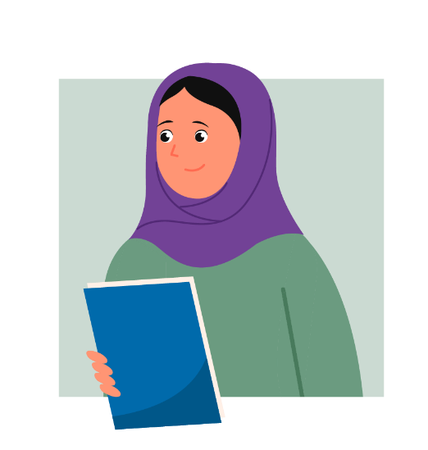

“Not an easy area to understand, but you will soon just begin to follow legislation through the daily routines in the setting, all of which will be arranged around policy and procedures to keep children, young people and all of those using and working within the setting safe. Learning about the legislation will help you once you are in your placement. It will also help you with your course work and achieving criteria relating to legislation.”

You may be asked to read a document called ‘Keeping children safe in education part 1’ when you start your placement. This is statutory guidance for schools and colleges. Statutory means something is relating to rules or laws.

If you didn’t chose to research it as part of the previous task, why not have a look at it now?

[assets.publishing.service.gov.uk/government/uploads/system/uploads/attachment_data/file/836144/Keeping_children_safe_in_education_part_1_2019.pdf](https://assets.publishing.service.gov.uk/government/uploads/system/uploads/attachment_data/file/836144/Keeping_children_safe_in_education_part_1_2019.pdf)

## **Considering health and safety procedures in school or college**

As with any organisation, there are specific health and safety procedures that settings and their staff must adhere to at all times. These are in place to keep not only the staff, but also the children safe, whilst they are in your care.

Typical checks can include:

* are the fire exit doors or routes unobstructed, kept unlocked and easy to open from the inside?
* are fire evacuation procedures clearly displayed?
* the evacuation drill in an emergency
* are procedures in place to deal with spillages eg water or blood for cuts and grazes?
* who are the trained First Aiders and Fire Marshalls within the school or college?
* what risk assessments are carried out?

If you’re unsure about any of these health and safety procedures, always make sure you check with a member of staff once on placement. It is a joint responsibility to ensure you are safe – both your own and the placement manager and staff.



“So now you have started to explore legislation and policies and procedures, a big topic area with lots of information to absorb, how did you do? Do you feel more confident that you will have a better understanding of these when you go into your placement?”

### **Activity**

The following form may be useful for when you start your placement. Keep it safe and use it to reflect on the some of the areas of learning covered so far in Module 1 and 2.

|  |  |
| --- | --- |
| Induction date |  |
| What time should I arrive?  Do I need to sign in?  What time do I leave?  What room do I go to? |  |
| Is there a dress code?  Is there anything I cannot wear?  Do I need a uniform?  Do I need an ID badge? |  |
| What documentation do I need to take for the qualification I am studying? | You should take a copy of the  Skills/Be Able To from the qualification specification |
| Do I need to know about policies and procedures? |  |
| **To be completed when induction day has taken place** | |
| Reflection  What did you learn about?  Do you feel more prepared now?  What did you forget to ask? | Write about the induction day here. |
| Mentors name  Any questions for your mentor? |  |

### **Activity**



“So, if you signed up to CACHE Alumni, take time now to use your membership and complete the online learning modules on safeguarding and e-safety. Come back once you have completed these.

How did you find the modules? Helpful I hope. All of the knowledge you have gained throughout the Preparing for Placement modules will help you so much, not only with your placement once you are able to access the settings but also with your coursework so keep going.”

Write a short piece about what you learnt in the safeguarding and e-safety online learning modules, also let us know how you found them, were they easy to use? Interactive enough for you? Write about the good and the bad.

## **Topic 7: The impact of Covid-19 on schools and colleges**

Of course, the world is a different place at the moment, we all have to learn how to live in the new normal. This will mean that when you do get into placement, you will need to take precautions to protect yourself, your colleagues and of course the children and young people that you will be working and interacting with. This topic aims to help you understand what this may look like.

Firstly, take a look at the government guidelines which are valid at this point in time (1 June 2020) of course things may have changed by the time you are working through this module but updated information will be posted on the government website so check this link is still the most update version.

<www.gov.uk/government/publications/coronavirus-covid-19-implementing-protective-measures-in-education-and-childcare-settings/coronavirus-covid-19-implementing-protective-measures-in-education-and-childcare-settings>

There is such a lot to read here, so try breaking it down, this document and the section ‘Effective infection protection and control and personal protective equipment (PPE) including face coverings and face masks’ will be important for you.

<www.gov.uk/government/publications/coronavirus-covid-19-implementing-protective-measures-in-education-and-childcare-settings/coronavirus-covid-19-implementing-protective-measures-in-education-and-childcare-settings>

This section has 6 points which are worth remembering not only in your placement but for every day where you will have contact with others. Read the section and then see if you can answer the questions we have set for you.

* Minimise contact with individuals who are unwell
* Clean your hands often
* Respiratory hygiene
* Clean surfaces that are touched frequently
* Minimise contact and mixing
* Personal protective equipment (PPE)

<www.gov.uk/government/publications/safe-working-in-education-childcare-and-childrens-social-care/safe-working-in-education-childcare-and-childrens-social-care-settings-including-the-use-of-personal-protective-equipment-ppe>

### **Activity**

Answer the following questions:

How does the transmission of Covid-19 mainly occur?

In schools or colleges, preventing the spread of Covid-19 involves what?

Describe the required handwashing routine

## **What is PPE?**

PPE stands for personal protective equipment. It includes items such as masks, eye protection, safety helmets, aprons and high visibility clothing – wearable items which are designed to keep people safe.

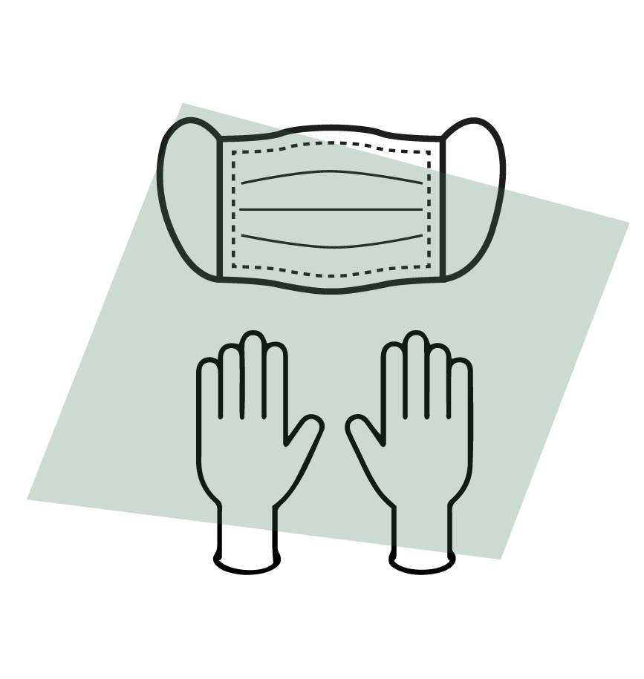

Why is PPE important?

This equipment helps reduce the risk of people coming to harm.

The need for PPE should be identified through risk assessment.  As with all risk assessments, those carrying them out must be competent to do so and have the necessary knowledge and experience of the methods of work.

Key workers such as NHS staff are wearing masks and visors, gloves and gowns. This is to help stop the spread of Coronavirus, if they are used properly they can help save lives. They stop contact with the virus in the air when people cough or sneeze.

Government guidance <www.gov.uk/government/publications/coronavirus-covid-19-implementing-protective-measures-in-education-and-childcare-settings/coronavirus-covid-19-implementing-protective-measures-in-education-and-childcare-settings#effective-infection-protection-and-control> says that “Changing habits, cleaning and hygiene are effective measures in controlling the spread of the virus”.

The guidance also recommends infection control measures including “cleaning hands more often than usual - wash hands thoroughly for 20 seconds with running water and soap and dry them thoroughly or use alcohol hand rub or sanitiser ensuring that all parts of the hands are covered”.

Furthermore, the guidance advises schools to “ clean surfaces that children and young people are touching, such as toys, books, desks, chairs, doors, sinks, toilets, light switches, bannisters, more regularly than normal”.

What else did you find out from reading this guidance?

### **Resources**

Here are some resources and activities which you could use with children once you are in your setting:

The 2 metres apart activity is here:

<https://cdn-busybees.ams3.digitaloceanspaces.com/downloads/twoMetreActivity.pdf>

How to wash your hands correctly:

[www.nhs.uk/live-well/healthy-body/best-way-to-wash-your-hands/](www.nhs.uk/live-well/healthy-body/best-way-to-wash-your-hands)

There is also a story book - Don’t Worry Little Bear - which could help you explain to the children about Covid19:

[subscriptions.earlyyearsstorybox.com/dont-worry-little-bear-book-updated/?_ga=2.180299489.498630501.1592988102-1693090358.1592988102](https://subscriptions.earlyyearsstorybox.com/dont-worry-little-bear-book-updated/?_ga=2.180299489.498630501.1592988102-1693090358.1592988102)

Dr Dog:

[www.lydiamonks.com/wp-content/uploads/2020/04/DrDogDoc.pdf](https://www.lydiamonks.com/wp-content/uploads/2020/04/DrDogDoc.pdf)



“Great! You are progressing through the programme really well! So far the focus has been on things you need to do or think about before you begin your placement, so that you get off to a great start.”