Assessment Innovation Fund (AIF) Evaluation Framework

Our vision
Our vision is to break the boundaries of assessment within education and promote innovation that creates robust and reliable assessment within an intelligent education ecosystem.

Assessment will build trust, confidence, and value to all stakeholders including learners, educators, employers and government. The approaches and solutions we will use to deliver assessment and insight to stakeholders will be inherently fair and will provide an appropriate level of ‘recognisable value’ to all stakeholders who have invested in learning. By assessment, we mean any activity that measures current knowledge, skills or behaviour at any stage of the learner value chain.

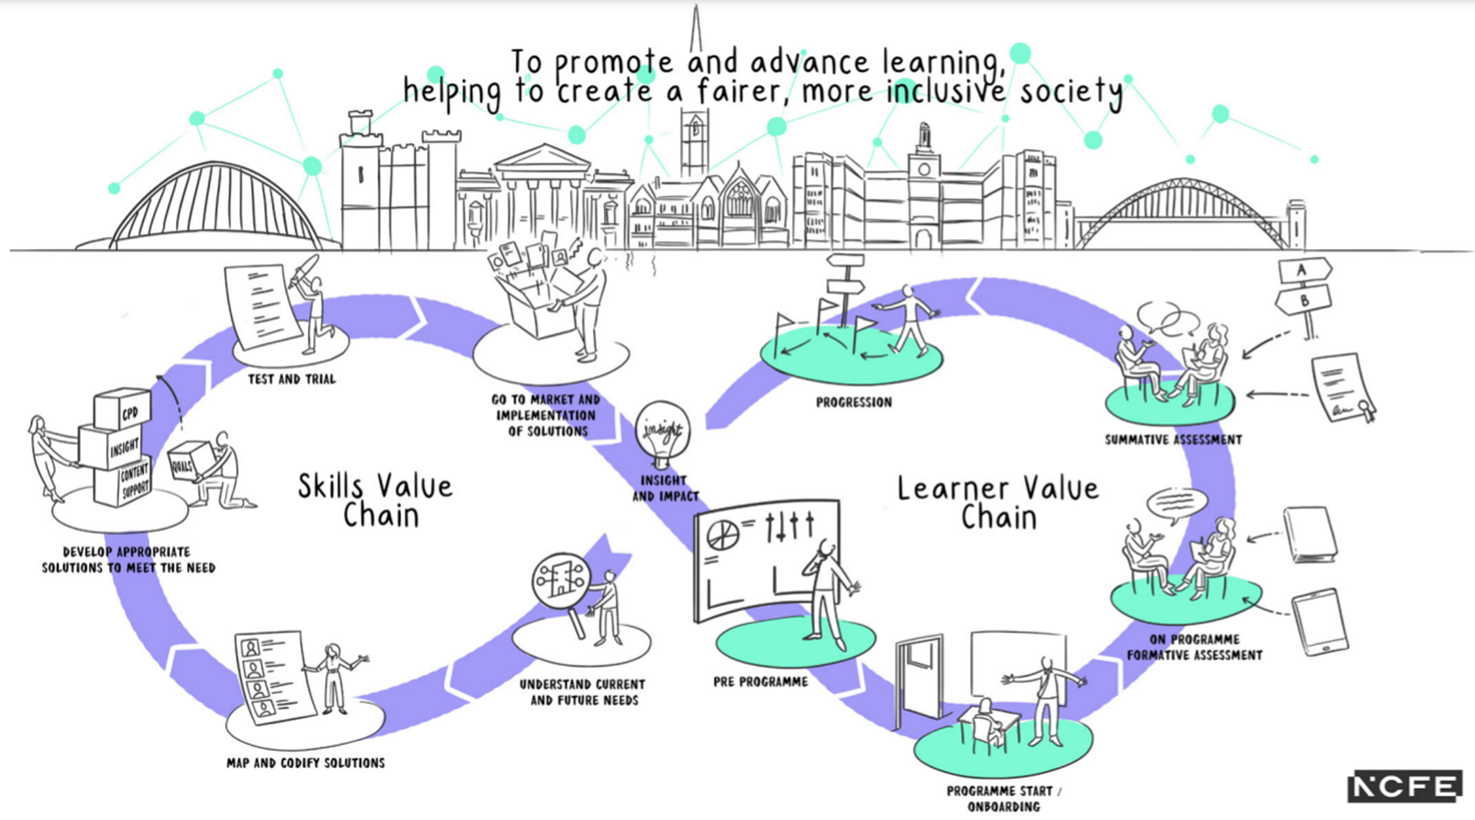
To do this we need an approach to assessment that:
- connects data across diagnostic, formative and summative assessment to provide insight into progress, trajectory and any required course corrections;
- uses insight to improve teaching, learning and assessment , allowing leaders and educators to promote high expectations for achievement and progress;
- enables learners and educators to use data provided from assessment to make informed choices about their next steps and make the best choices in line with their desired goals, stretching and challenging learners to achieve beyond their expectations;
- supports the learner to develop agency and improves their ability to learn alongside the knowledge skills and behaviours they acquire within their subject specific programme.

Assessment Innovation Fund (AIF)
The Assessment Innovation Fund (AIF) will be a catalyst for change by providing evidence-based, alternative assessment solutions.

The AIF will be open to applications from any organisations with an interesting idea about what the Assessment Innovation might look like.

Applicants will need to be able to demonstrate:
- the issue that the innovation is trying to solve;
- how the innovation will address the issue;
- how the innovation will impact learners (NCFE’s beneficiaries);
- that the innovation is linked to at least one of the guiding principles for Assessment Innovation (Annex 1 : Element Descriptors);
- sound assessment methodology;
- value for money, reach and impact;
- that robust processes are in place to ensure high quality design, development, delivery and evaluation of assessment, including technology and resource requirements and consideration of sustainability and scalability following the conclusion of the pilot;
- a clear understanding of the costs associated with the design, development, delivery and evaluation of the assessment;
- awareness of any policy, funding and regulatory implications;
- that they have considered and put controls in place to meet any ethical standards and legal requirements;
- impact on practice and any training requirements;
- an understanding of the risks associated with the design, development, delivery and evaluation of assessment and has sufficient controls in place.

Funding allocation
Initial funding will be for a 12-month programme of activity.

Up to a maximum sum of £100,000 will be allocated per pilot. In addition, we will make funding available to support pilots to engage with technology. NCFE will hold the relationship with all technology partners.

Technology partners must be approved in writing by the NCFE Technical Design Authority (TDA) in advance of any engagement.

Funding will be profiled in line with the duration of the pilot and payment will be made in line with quarterly reporting and will be dependent upon the successful achievement of project milestones.

Application Process

The selection process will consist of a two-stage application process where access to Stage 2 will be by invitation only. Evaluation is undertaken by an Expert Panel who have been selected based on their experience and expertise in relation to the area of assessment innovation. The Expert Panel consist of a mix of both NCFE internal staff and external representatives who are from a variety of backgrounds and areas of expertise including: academic, awarding, EdTech, and regulatory bodies. By applying, the applicant acknowledges that the information contained within the application will be shared with the panel members to allow for scoring.

The applicants will be awarded a share of the AIF subject to the final approval of the NCFE executive team operating through the integrated programme board (IPB).

The application process can be summarised as follows:

Stage 1: This is an online written application which will outline the problem that the innovation aims to address as well as demonstrating the potential impact, feasibility, robustness, and suitability of the proposed assessment innovation. The assessment approaches and solutions will be inherently fair and will provide an appropriate level of ‘recognisable value’ to all stakeholders who have invested in learning.

Stage 2: If applicants are successful in Stage 1 of the process, they will be invited to present to the Expert Panel. The presentation will focus on the rationale for the solution, research methodology and associated risks, high-level project plan and budget in more detail. The overall aim of this stage is to ‘deep dive’ into the proposal to ensure alignment with the AIF objectives (see Annex 1: Element Descriptors) as well as allowing for open dialogue between the Expert Panel and the applicant(s).

The structure of Stage 2 will be as follows:
Item | Timing
Introduction | 10 minutes
Presentation | 30 minutes
Q&A from Expert Panel | 20 minutes
Q&A from applicant | 10 minutes

Scoring

Stage 1
Each Element (see Annex 1: Element Descriptors) in the Application Form has an associated weight in the overall evaluation as indicated in the table below and will be scored using this.

Prior to Expert Panel awarding scores, a pre-screening exercise will take place by the Assessment Innovation team. Where a score of major concerns (scoring of “1 – Very Weak Confidence” for an element by the team) are awarded by the Assessment Innovation team, the applicant will be excluded from further participation.

In addition, where concerns about ethics, confidentiality and/or conflicts of interests are identified, NCFE reserves the right to exclude the applicant from further participation in the process.

Category | Element | Weighting (%)
Suitability and impact (50%) | Alignment to Assessment Innovation Strategy | 20%
 | Potential impact to Learners | 15%
 | Scalability and sustainability | 15%
Feasibility (25%) | Cost | 10%
 | Time | 10%
 | Delivery | 5%
Robustness (25%) | Methodology principles | 15%
 | Risk and uncertainty | 10%
Wider considerations | Ethics and confidentiality | Not scored.  Where ethical or confidentiality conflicts are identified NCFE reserves the right to exclude the applicant from further participation in the process.
 | Conflicts of Interest | Not scored.  Where conflicts of interest are identified NCFE reserves the right to exclude the applicant from further participation in the process.

Stage 2
Stage 2 provides applicants the opportunity to present their proposal in further detail as well as allowing for open dialogue between the Expert Panel and the applicant(s).

Each Element in the presentation has an associated weight in the overall evaluation as indicated in the table below and will be scored using this.

Element | Description | Weighting (%)
- Potential impact to learners | - The innovation is founded upon sound understanding of the ‘problem area’ and provides a clear, well-defined solution that addresses the problem.  - The pilot provides well-defined outcomes for learners and there is a logical connection between the solution identified and intended impact. | 30%
- Scalability and sustainability | - The pilot applicant has an understanding and vision of how to scale the solution.  - The pilot applicant understands their customer and has evidence of market demand for the solution.  - The pilot applicant understands how the solution would be funded beyond the pilot. | 20%
- Project planning | - Project timelines and forecasted budget are realistic as well as providing value for money and time.  - Project costs are clearly defined, and procurement of assets is transparent.  - Project timelines are clearly defined, and responsibilities are transparent. | 20%
- Research methodology | - Research methodology is robust, reliable, and fair as well as designed to measure the impact that the proposal sets out to achieve.  - Risks and uncertainties are suitably mitigated and deemed appropriate within the accepted risk threshold for the pilot. | 20%
- Leadership and team | - Applicant(s) have acquired, or are able to acquire, the relevant network(s), skills and resources required to deliver the proposal. | 10%

The following scoring methodology will be applied to responses:

Score | Commentary
1 | Response provides NCFE with a weak level of confidence in the applicant’s ability to meet its requirements.
2 | Response provides NCFE with a moderate level of confidence in the applicant’s ability to meet its requirements.
3 | Response provides NCFE with a strong level of confidence in the applicant’s ability to meet its requirements.
4 | Response provides NCFE with a very strong level of confidence in the applicant’s ability to meet its requirements.

Feedback

We will provide initial feedback to applicants who are unsuccessful at Pre-screening and Stage 1 based on the scoring of the Assessment Innovation team and Expert Panel. Applicants can expect to receive numerical scoring at this stage.

We will provide detailed feedback for applications that are unsuccessful following Stage 2 based on the scoring and dialogue provided from the Expert Panel.

For applications where we feel that the suitability and impact are aligned to NCFE’s guiding principles, but the application lacks the necessary robustness and feasibility, we may offer further guidance and resource.

Annex 1: Element Descriptors

Suitability and impact
Title | Alignment to Assessment Innovation Strategy
Weight | 20%
Aim | To provide confidence that the proposal is sufficiently aligned to a minimum of one of the following Assessment Innovation guiding principles:  - Delivers a transformational learning and assessment experience for all learners that considers meta and technical skills development and provides learners with the insight and support they need to develop agency.  - Enables personalisation in assessment by exploring the opportunities and limitations to personalisation within assessment.  - Tests and evaluates a range of assessment methods and practices that support the development of an assessment system that is fair and inclusive by design and moves away from high stakes, stressful exams where appropriate to do so.  - The balance and interplay of formative and summative assessment and the implementation of technology to make assessment more readily available and fit for purpose and building a real-time picture of the impact of the learning.  - Establishes a culture that promotes innovation within vocational and technical education, training and assessment by working in partnership with regulators and the Department for Education to test and evidence new solutions and practices.  - Uses data and technology in insightful and efficient ways to enable high quality teaching, learning and assessment removing the disconnect in data across the learner journey and taking account of data that exists on prior learning and experience.  - Using data more collaboratively and throughout the whole learner journey to improve the level of perceived value of assessment processes as a means of enabling choice, understanding needs and progress and informing every stage of the learning journey.

Title | Potential impact to Learners
Weight | 15%
Aim | To provide the confidence that the proposal has clear and impactful benefit to the learner based on the Assessment Innovation guiding principles above as well as at least one of the following success criteria:  - Empowers learners and educators to make the best possible choices about learning.  - Equips contributors to learning with the expertise and resources to deliver transformational learning experiences.  - Supports learners to develop wider skills such as “agency” so that they are better prepared to succeed within an evolving labour market.  - Inspires all those who participate in learning to give back more than they took out.  - Supports educators to improve teaching, learning, assessment, outcomes and progression of learners.  - Provides learners with assessment that: is fair and inclusive; is available as part of a formal qualification or programme; recognises prior learning and competence; on-demand and multi-channel; is tailored to the delivery context and learner needs; is robust, secure, and credible to all stakeholders; supports continuous improvement in the learning experience; is converted into a recognised store of value, whether credential or otherwise.

Title | Scalability and sustainability
Weight | 15%
Aim | To provide the confidence that the applicant(s) understands how the solution may provide future public benefit beyond the pilot. The applicant(s) should demonstrate the following criteria:  - The applicant has an understanding and vision of how to scale the solution following conclusion of the pilot.  - The applicant understands their customer and has evidence of market demand for the solution.

Feasibility

Title | Cost
Weight | 10%
Aim | To provide confidence that the proposal has been adequately resourced in terms of pricing and that this delivers value for money.

Title | Time
Weight | 10%
Aim | To provide confidence that the proposal has been realistically and optimally resourced in terms of time.

Title | Delivery
Weight | 5%
Aim | To provide confidence that the applicant’s experience which will ensure they are successful in delivering the pilot as well as that the applicant has the required means to access the tools/resources required to prototype their solution and adequately perform research methodology.
Robustness

Title | Methodology Principles
Weight | 15%
Aim | To provide confidence that the research methodology proposed would be suitable in facilitating the creation of unbiased, reliable, valid and comparable key performance indicators (KPI’s) to measure the pilot’s success.

Title | Risk and uncertainty
Weight | 10%
Aim | To provide confidence that the risks and uncertainties are suitably mitigated and deemed appropriate within the accepted risk threshold for the pilot.

Further Considerations

Title | Ethics and confidentiality
Weight | N/A
Aim | To provide confidence that the ethical and confidentiality requirements of the pilot have been considered.

Title | Conflict of Interest
Weight | N/A
Aim | To provide confidence that conflicts of interest within the pilot have been considered.

