Name
Tutor/Department
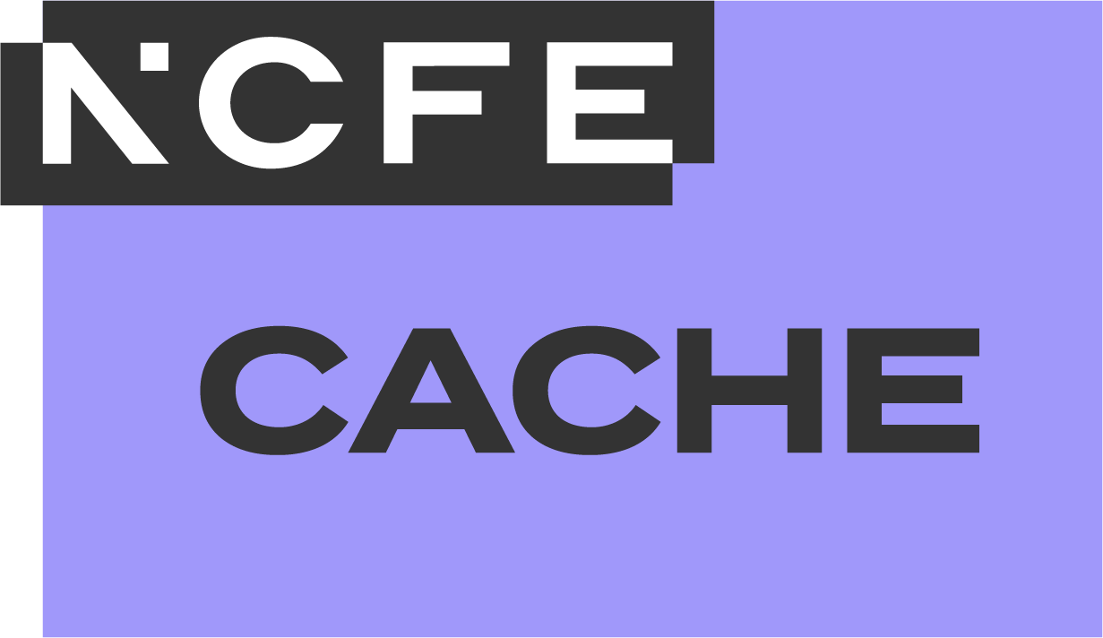
NCFE CACHE Level 3 Diploma for Working in the Early Years Sector (Early Years Educator)
610/4164/6
NCFE CACHE Level 3 Technical Occupational Entry for the Early Years Workforce (Early Years Educator) (Diploma)
610/3984/6
NCFE CACHE Level 3 Extended Diploma for Working in the Early Years Sector (Early Years Educator)
610/6133/5

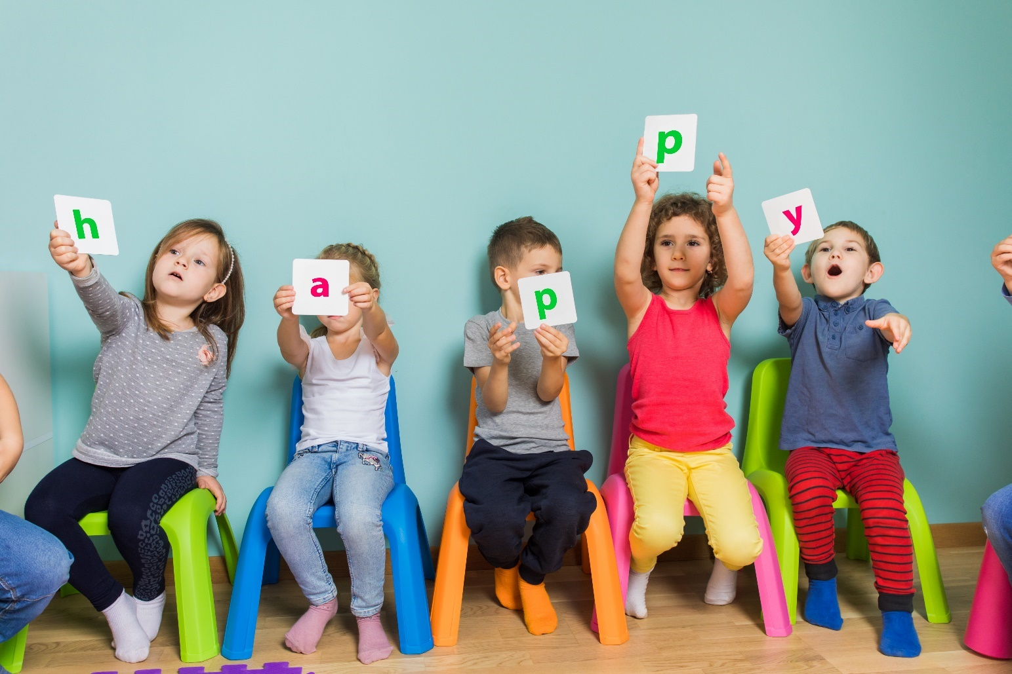
Learner Guide
Units 1 to 10
Copyright notice
© NCFE 2025. All rights reserved. No part of this document may be reproduced, distributed, or transmitted in any forms or by any means, including photocopying, recording, or other electronic or mechanical methods, without the prior written permission of NCFE.
NCFE resources available in a digital format can be adapted to learners’ needs but trademarks, copyright or other proprietary notices cannot be deleted or modified without permission.
The content of this document is, unless otherwise indicated, the intellectual property of NCFE. Users are permitted to view, print, and download the material for personal, non-commercial and classroom use (for example, non-commercial use by a qualified educational institution) only. Users are not permitted to remove or amend trademarks, copyright, or other proprietary notices.
Version | Publication year | Description of change
V1.0 | July 2024 | First publication
V2.0 | August 2025 | This learner guide can now also be used by those delivering the NCFE CACHE Level 3 Technical Occupational Entry for the Early Years Workforce (Early Years Educator) (Diploma) (610/3984/6) qualification. References to this qualification have been made throughout the guide. Minor formatting changes have also been made.
V3.0 | October 2025 | This learner guide can now also be used by those delivering the NCFE CACHE Level 3 Extended Diploma for Working in the Early Years Sector (Early Years Educator) (610/6133/5) qualification. References to this qualification have been made throughout the guide. Minor formatting changes have also been made.
Disclaimer
NCFE resources are optional support tools and are not essential to the delivery of the relevant qualification. They provide an interpretation of how the subject content listed in the Qualification Specification can be delivered. They are written and reviewed by subject experts independently to the Qualification Specification and to the assessment materials. The content included in these resources does not indicate any content coverage in summative assessment materials.
Centres must refer to the Qualification Specification for the relevant qualification for full details of the mandatory content of the qualification. The teaching guidance section of the Qualification Specification is advisory and provides useful guidance to support delivery of the teaching content of the qualification.
The content of these resources is correct at the time of publishing but may be subject to change.

Contents
Contents 3
Introduction 4
Unit 1 5
Introduction to the role of the early years educator 5
Unit 2 12
Holistic child development 12
Unit 3 18
Children with special educational needs and disabilities (SEND) 18
Unit 4 24
Effective communication in an early years setting 24
Unit 5 31
Safeguarding and welfare requirements 31
Unit 6 38
Health, wellbeing and safety 38
Unit 7 51
Promoting an effective early years curriculum 51
Unit 8 62
Assessment of children’s learning and development 62
Unit 9 67
Understanding play for learning and holistic development 67
Unit 10 73
Partnership working 73
Workplace diary 81
Feedback and reflection 85
Contact us 89

Introduction
This learner guide is designed to support the knowledge, skills and understanding required for units 1 to 10 of the Level 3 Diploma for Working in the Early Years Sector (Early Years Educator), the Level 3 Technical Occupational Entry for the Early Years Workforce (Early Years Educator) (Diploma) and the Level 3 Extended Diploma for Working in the Early Years Sector (Early Years Educator) qualifications. A learner guide for units 11 to 16 of the Level 3 Extended Diploma for Working in the Early Years Sector (Early Years Educator) qualification can be found on its qualification page.
These tasks offer additional learning support, providing opportunities to gain knowledge that can be applied to work in an early years setting. Providers are invited to utilise any of the tasks according to learning context, needs of the learner and job roles, to complement teaching and learning in preparation for formal assessment or consolidation of knowledge to check understanding.

Towards the end of the learner guide, there is a workplace diary; this can be used to help recognise new skills as well as areas for improvement following each week or work placement session. Also included are feedback and reflection sheets to help further develop knowledge and skills following any groupwork such as presentations, peer feedback and tutor and/or assessor feedback.
Please note: to avoid any conflict of interest, learning resources are developed without insight into assessment materials. This resource contains no summative assessment.

Unit 1

Introduction to the role of the early years educator




Unit 1 learning objectives
LO1 | Understand the professional roles and responsibilities required to work in an early years setting.
LO2 | Understand procedures that must be adhered to in the work setting and their importance.
LO3 | Understand the role of supervision.
LO4 | Understand professional development.
LO5 | Be able to use and model good communication skills, including a good command of the English language in spoken and written form.
LO6 | Be able to explain own role, responsibilities and expected behaviours, and the roles of colleagues in the setting and team.
LO7 | Be able to explain how our own and others’ behaviour can impact on babies and children and the importance of role-modelling positive behaviours.
LO8 | Be confident in supporting or challenging the practice of colleagues, including difficult conversations.
LO9 | Be able to follow procedures in the work setting, including, where appropriate, updating and developing policies and procedures.
LO10 | Be able to foster a culture of mutual support, teamwork and continuous improvement that encourages confidential discussion of sensitive issues, through effective supervision at all stages of career.
LO11 | Be able to seek out feedback from others and use reflection to identify and support career development and personal goals.


Activity 1: roles and responsibilities
Review a job description for an early years educator and identify the skills you already have.
You should consider your:
- knowledge
- skills
- behaviours
List below any gaps in your knowledge, skills and behaviours.
What improvements could you make?


Activity 2: other roles in the early years setting
Outline the roles and responsibilities of the colleagues who would be part of your team in an early years setting.


Activity 3: developing personal goals (SWOT)
Identify your strengths, weaknesses, opportunities and threats (SWOT) for the roles and responsibilities of an early years educator and complete the table below. You could use a job description or the early years educator apprenticeship standard to support your thinking.
Consider the skills knowledge and behaviours you need when setting goals and making plans. They might include:
- strengths: what you are good at
- weaknesses: what you are not so good at
- opportunities: skills, experiences and knowledge you could gain that might help you towards your goals
- threats: skills, experiences and knowledge you lack that could delay your plans
This activity will enable you to develop your skills, knowledge and behaviour as well as prepare you to recognise opportunities and adapt to problems.
Strengths | Weaknesses
Opportunities | Threats
Create a development plan to support your goals and harness your ‘strengths’ and ‘opportunities’. Include strategies to overcome any ‘weaknesses’ and to mitigate any ‘threats’.


Activity 4: policies and procedures
Research and summarise the various policies and procedures followed in an early years setting.
You might consider:
- reporting and types of records expected
- whistleblowing procedures
- protecting and promoting the welfare of children
- safeguarding requirements
- confidentiality
- information sharing
- use of technology
- referring development concerns
- protecting yourself (for example, media and online presence)
- staff health and safety, including mental health and wellbeing support and supervision

Unit 2

Holistic child development

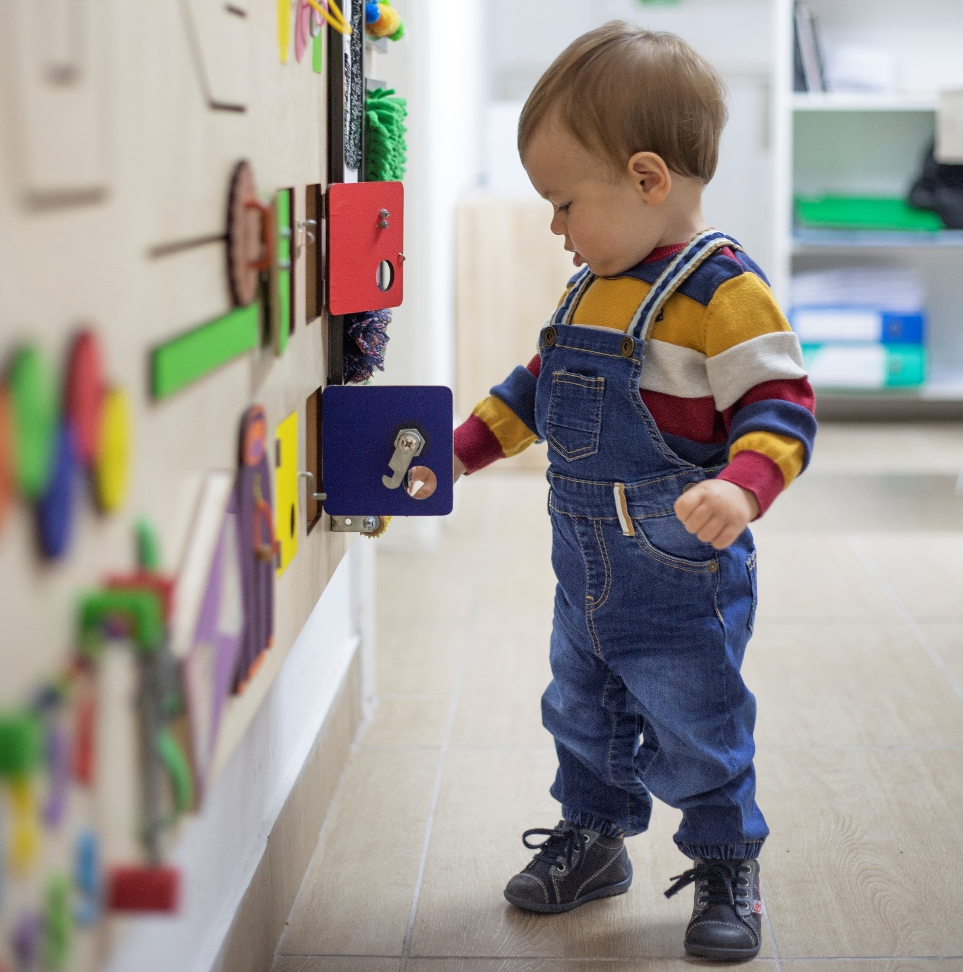

Unit 2 learning objectives
LO1 | Understand the expected patterns of babies’ and children’s development from conception to seven years old.
LO2 | Understand key milestones for holistic development from birth to seven years.
LO3 | Understand the influence of key individuals and the importance of attachments that shape babies’ and children’s social world and underpin their holistic learning and development.
LO4 | Understand the significance of physical, mental and emotional health and wellbeing for babies’ and children’s development.
LO5 | Understand co-regulation and self-regulation in children.
LO6 | Understand a range of evidence-based theories and research that underpin early years development.
LO7 | Be able to prepare and support babies and children through transitions and significant events in their lives.
LO8 | Be able to support children to form positive attachments.
LO9 | Be able to promote health and wellbeing in settings working with babies and children from birth to five years.
LO10 | Be able to support children to develop a positive sense of self and to recognise, understand and manage their emotions, including supporting a child’s understanding of differing emotional reactions and what may or may not be appropriate.
LO11 | Be able to apply evidence-based theories in practice, and as appropriate, based on a clear understanding of cognitive science (reliable theory).

Activity 1: stages of development
Children go through a lot of changes as they develop. List the stages of development in babies and children from conception to seven years.
You might want to consider:
- cognitive development
- neurological and brain development
- speech, language and communication development
- physical development
- personal, social and emotional development

Activity 2: theories around attachment
Many individuals influence babies and children throughout their development. List the key individuals who can influence a child’s development.
List theories around attachment in early years development.
Choose one theory around attachment, summarise its main points and make reference to current practice.


Activity 3: evidence-based theories
Research the following evidence-based theories and summarise what they say about early years development.
Athey
Bandura
Bruner
Donaldson
Nutbrown
Piaget
Vygotsky

Activity 4: transitions and significant events
What transitions and significant events do babies and children typically experience from birth to seven years?
In an early years setting, how might an early years educator support a child through a micro transition?

Unit 3

Children with special educational needs and disabilities (SEND)



Unit 3 learning objectives
LO1 | Know about legislation and guidance for children and young people with special educational needs and disabilities (SEND).
LO2 | Understand that there are appropriate strategies for supporting a baby or child with SEND.
LO3 | Understand that there are specialist aids, resources, and equipment available to support babies and children with SEND.
LO4 | Be able to explain and apply the early years foundation stage (EYFS) statutory framework and SEND code of practice in relation to the care and education of babies and children with SEND, through a graduated approach.
LO5 | Be able to work effectively in partnership with others (or alongside colleagues), including parents and carers, to promote and implement appropriate strategies for supporting the progress of babies and children with SEND.
LO6 | Be able to effectively carry out a child’s care plan (or shadow a colleague) alongside parents and carers, including the initial assessment, implementation, and ongoing review.
LO7 | Be able to promote and encourage a working environment that values and respects the individual developmental needs and stages of babies and children with SEND.
LO8 | Be able to use specialist aids, resources and equipment available to support babies and children with SEND.
LO9 | Be able to analyse and explain how cultural background and family circumstances can impact on babies’ and children’s learning and development.

Activity 1: legislation and frameworks
Research and summarise the following legislation and statutory and non-statutory frameworks for provision in early years.
SEND code of practice
Equality Act 2010
Early years foundation stage (EYFS) statutory framework
What are the implications of not following legislation and frameworks for provision in early years?

Activity 2: inclusive practice
Being inclusive is to understand that all children are entitled to a quality education that is appropriate to their unique needs, promotes high standards and encourages the fulfilment of their potential.
Give examples of how an early years educator can apply inclusive practice to support a baby or child with SEND.

Activity 3: specialist equipment
Identify specialist equipment that can support babies or children with SEND and describe their functions.

Activity 4: cultural background
How can cultural background and family circumstances impact on the learning and development of babies and children?
You should consider:
- caregiving style
- customs and beliefs
- language
- socio-economic background

Unit 4

Effective communication in an early years setting

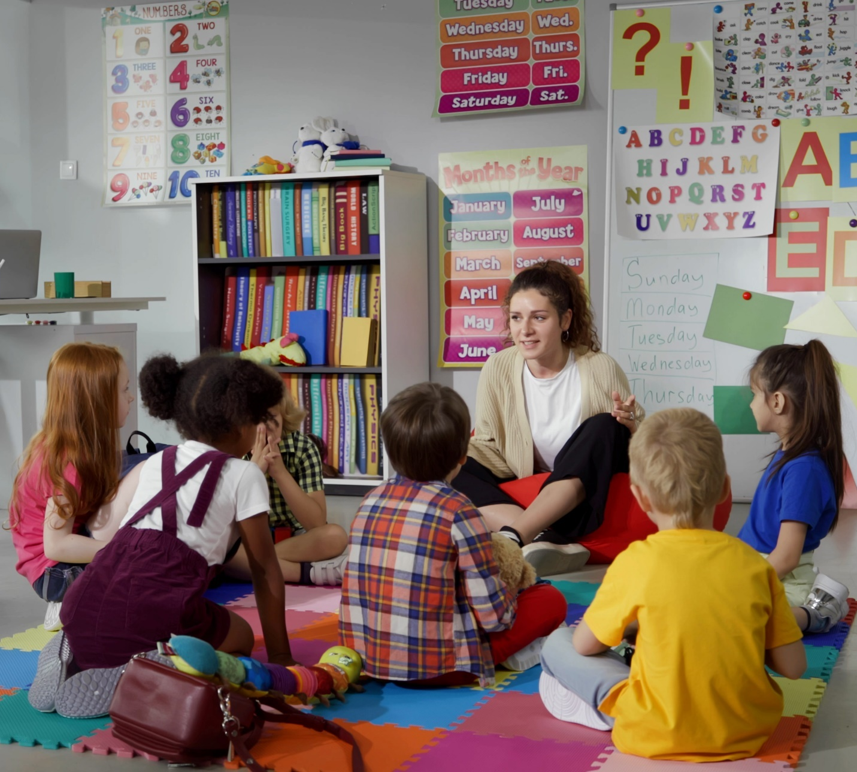

Unit 4 learning objectives
LO1 | Understand the impact of an effective communication and language curriculum that offers positive benefits to babies’ and children’s development.
LO2 | Understand that children develop at their own pace in language development and can experience speech and language difficulties.
LO3 | Understand that there are ways to communicate with all children, appropriate for their stages of development.
LO4 | Be able to develop, support and promote babies’ and children’s speech, language, and communication through effective planned adult interactions.
LO5 | Be able to identify delays in communication development and describe appropriate support services for babies and children.
LO6 | Be able to communicate with all children in ways that will be understood, including verbal and non-verbal communication, to extend their learning and development.
LO7 | Be able to help children catch up with language development through planned use of pronunciations, words and phrases.
LO8 | Be able to adapt teaching approaches, as appropriate to ensure children with speech and language difficulties, and those for whom English is an additional language (EAL), are supported to catch up.
LO9 | Be able to apply a range of communication methods for effective collaborative working.

Activity 1: effective communication and language
Research and summarise key features of a language rich environment to promote effective communication and language in an early years setting.
How could you plan interactions with babies and children? These interactions, either one to one or in groups, would promote speech, language and communication. An example would be an early years educator reading a story to a small group of children.

Activity 2: language acquisition
Research and summarise the stages of language acquisition.

Activity 3: language difficulties
Identify speech and language difficulties that babies and children may experience as they learn to communicate.

Activity 4: speech and language support
Identify how an early years educator can support babies and children with speech and language difficulties, including specialist early intervention.
Research and summarise support services for babies and children with communication development delays or speech and language difficulties.

Activity 5: communication methods
An early years educator should communicate with children in ways that will be understood, including verbal and non-verbal communication, to extend the child’s learning and support their development.
List a range of communication methods that can be used in an early years setting.
You should consider:
- verbal communication
- non-verbal communication
- other professionals
- technology

Unit 5

Safeguarding and welfare requirements



Unit 5 learning objectives
LO1 | Understand the signs of harm and the different types of abuse and what these are.
LO2 | Understand legislation, policies and procedure in relation to keeping children safe.
LO3 | Understand an early years educator’s role and responsibilities in relation to keeping children and colleagues safe.
LO4 | Be able to recognise when a baby or child is in danger or at risk of abuse, including online, and know how to act to protect them.
LO5 | Be able to find and stay updated on employer, local and national safeguarding policies and procedures, as set out in statutory and non-statutory guidance.
LO6 | Be able to follow Ofsted’s Whistleblowing policy to pass on information that, where it is reasonable to believe, shows wrongdoing or a cover-up by an employer’s organisation. This might be about activity that is illegal, risks others’ health and safety, is poor practice or fails to meet statutory requirements.
LO7 | Be able to carry out own role and act upon responsibilities, including providing appropriate supervision of others in relation to safeguarding and security, including child protection, duty of care, reporting and confidentiality of information.

Activity 1: legislation, policies and procedures
Research and summarise the legislation, policies and procedures below in relation to keeping children and colleagues safe in an early years setting.
Child protection | Equality, diversity and inclusion
Ofsted’s Whistleblowing policy | Safeguarding and welfare
Why must an early years educator stay up to date with changes to legislation?


Activity 2: keeping children safe
Create a mind map to identify the responsibilities of an early years educator for keeping babies and children safe.
You should consider:
- the appropriate supervision of others
- health and safety
- safeguarding and security systems
- child protection
- duty of care
- reporting and confidentiality of information
- safeguarding staff

Activity 3: abuse and harm
For each type of abuse, list the signs that a baby or child is in danger or at risk (some may overlap).
Neglect
Physical
Emotional
Online
Domestic
Sexual
For each type of harm, list the signs that a baby or child is in danger or at risk (some may overlap).
Female genital mutilation (FGM)
Sexual exploitation
Grooming
Bullying
Radicalisation
Discrimination

Activity 4: procedures
Describe the procedures an early years educator should follow when they suspect a baby or child is in danger or at risk of abuse or harm.

Unit 6

Health, wellbeing and safety



Unit 6 learning objectives
LO1 | Understand legal requirements and statutory guidance, as well as other non-statutory guidance on health and safety.
LO2 | Understand it is important to ensure equipment, furniture and materials are used safely and the dangers of not doing so.
LO3 | Understand the role of policy and procedure in maintaining the health, wellbeing and safety of babies and children.
LO4 | Understand that it is important to prevent and control infection.
LO5 | Understand the signs and symptoms of a child who is unwell or injured.
LO6 | Understand that it is important for babies and children to have a healthy, balanced and nutritious diet.
LO7 | Understand that it is important for babies and children to be physically active.
LO8 | Understand the importance of risk versus benefit.
LO9 | Be able to use equipment, furniture and materials safely following the manufacturer’s instructions and setting’s requirements, with regard for sleep safety. Assist others in the safe use of:  - equipment  - furniture  - materials
LO10 | Be able to identify and act upon own responsibilities in relation to:  - health  - safety  - wellbeing
LO11 | Be able to carry out risk assessments and risk management in line with:  - employer, local and national requirements  - policies and procedures
LO12 | Be able to maintain accurate and coherent records and reports and share information, when appropriate, to ensure the needs of all children are met.
LO13 | Be able to explain, plan, and carry out respectful care routines appropriate to the development, stage, dignity and needs of babies and children, to include their cultural, race, religion and belief systems.
LO14 | Be able to implement effective strategies for preventing and controlling infection.
LO15 | Be able to take appropriate action to respond to accidents and emergency situations.
LO16 | Be able to share information with parents and carers.

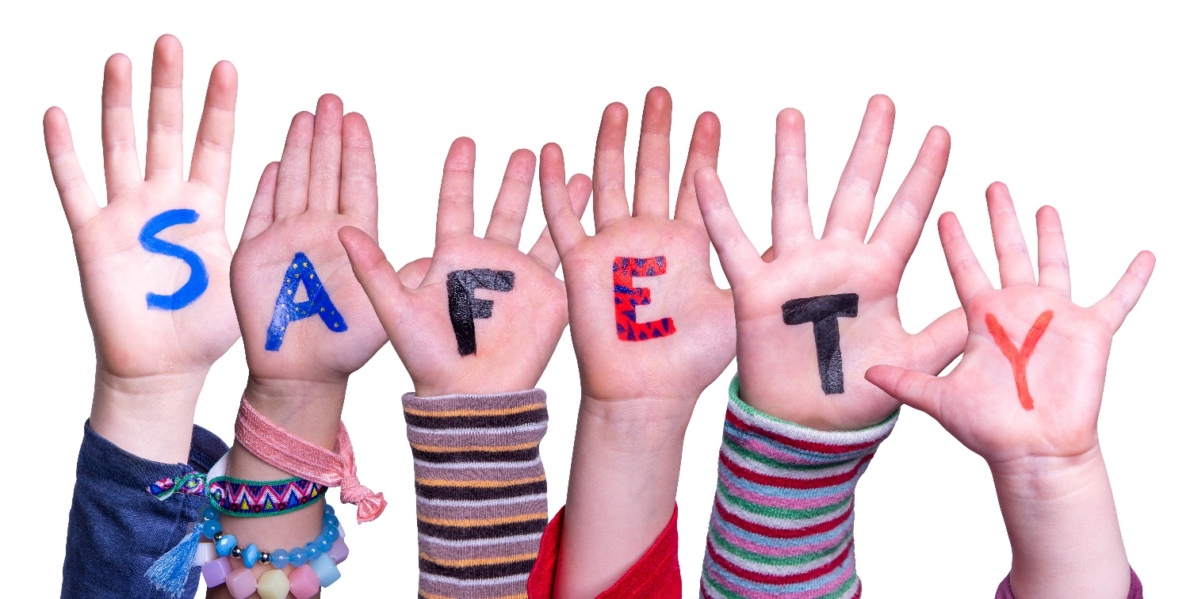
Activity 1: legal requirements
Research and summarise the legal requirements and statutory guidance on health and safety in an early years setting, including:
- Health and Safety at Work etc. Act 1974
- Control of Substances Hazardous to Health (COSHH)
- Reporting of Injuries, Diseases and Dangerous Occurrences Regulations (RIDDOR)

Activity 2: health, wellbeing and safety
Policies and procedures play an important role in maintaining the health, wellbeing and safety of babies and children.
Research the following policies and procedures and explain why they are important.
Accidents and emergencies
Confidentiality of information
Fire drills
Illness
Meals and snacks
Personal hygiene, including oral health
Risks and risk management
Routine safety checks
Security

Activity 3: incidents and accidents
List the reason for ensuring equipment, furniture and materials are used safely in an early years setting. What are the dangers of not doing this?
Despite best intentions, accidents can still happen. What advice could an early years educator offer in the following situations?
A baby or young child requires urgent medical attention.

A baby or young child requires urgent dental attention.
A baby or young child experiences a non-medical incident or emergency.

Activity 4: signs and symptoms
List the signs and symptoms of common childhood illnesses in an early years setting.
Childhood illness | Signs and symptoms | Treatment | Exclusion period

Activity 5: nutrition and weaning
Research and summarise nutritional guidelines for babies and children from birth to five years.
Review NHS guidance and highlight key stages of weaning in babies.

Activity 6: benefits of physical activity
Create a mind map to explore the benefits of physical activity for babies and children.

Activity 7: accurate records
Considering the categories below, explain why it is important to ensure that the following records are accurate.
Accidents and near misses
Daily registers
Health, safety and security
Medication requirements
Observations and assessments
Planning
Special dietary needs, including approaches to starting and storing solid foods

Activity 8: policies and procedures
Review the categories below for policies and procedures in an early years setting and summarise the role of an early years educator.
Care of skin, teeth and hair
Nappy-changing procedures
Potty and toilet training
Rest and sleep provision including sleep safety
Supervision of children whilst eating (feeding and weaning and complementary feeding)

Activity 9: preventing and controlling infection
Research policy and procedure in an early years setting. How could you prevent and control infection?
Dealing with spillages safely | Food hygiene
Handwashing techniques | Immunisation schedules
Safe disposal of waste | Using correct personal protective equipment (PPE)

Activity 10: sharing information
Considering the categories below, explain how you could share information (written or verbal) with parents and carers.
The importance of healthy balanced diets
The importance of maintaining good oral health
The importance of being physically active

Unit 7

Promoting an effective early years curriculum



Unit 7 learning objectives
LO1 | Understand how evidence-based philosophical and pedagogical approaches influence the early years foundation stage (EYFS) that sets out the early education curriculum requirements from birth to age five.
LO2 | Understand that all children and young people are entitled to an education, appropriate to their needs, which promotes high standards and the fulfilment of potential.
LO3 | Understand how the curriculum and pedagogical approaches to teaching are planned and adapted to create experiences and opportunities for children which appreciate that children are likely to have different levels of prior experience and knowledge, including how adaptive pedagogy promotes learning for all.
LO4 | Understand that a carefully planned and sequenced curriculum is essential for all children, in recognition of their needs and interests, to include adult-led explicit teaching, as well as child-initiated experiences.
LO5 | Understand that the learning environment, both indoors and outdoors, is a resource that supports the implementation of the curriculum.
LO6 | Promote equality of opportunity in the education and care of all children in early years provision, including children with special educational needs and disabilities (SEND).
LO7 | Be able to plan educational programmes that reflect the needs and interests of the children.
LO8 | Be able to use appropriate curriculum and practice support, such as the non-statutory Development Matters guidance.
LO9 | Be able to respond to the needs and interests of the child, to support intended learning.
LO10 | Be able to reflect on the impact of pedagogical approaches and values on the environment in an early years setting.
LO11 | Be able to select and combine the best pedagogical approaches, based on the curriculum and children’s prior knowledge.
LO12 | Be able to adapt teaching to suit babies’ and children’s different starting points, experience and knowledge.


Activity 1: learning and development
Review the early years foundation stage (EYFS) framework and outline the areas of learning and development.
Communication and language | Personal, social and emotional development
Physical development | Expressive arts and design
Literacy | Mathematics
Understanding the world | Other notes

Activity 2: examples of pedagogy
A pedagogical approach is the way educators design curriculum and plan content for teaching and learning delivery.
Give an example for each of the pedagogical approaches below.
Adult explanations
Adult modelling
Direct teaching
Guided learning
Learning from peers
Play

Activity 3: equality for all
All children and young people are entitled to a high-standard education that is appropriate and adapted to their needs. When providing an early years curriculum, educators should uphold principles of equality, diversity and inclusion.
Review the Equality Act 2010 and outline how you would apply these principles in an early years setting. You should consider children with SEND.

Activity 4: enabling environments
An early years educator should plan and adapt the curriculum and pedagogical approaches to teaching and learning to create experiences and opportunities for all children.
Give examples of learning experiences in indoor and outdoor environments and explain how they can support the development of all children.
Indoor
Outdoor
Using one of the examples above, how could you plan, resource and scaffold learning experiences for babies and children? You should consider current statutory requirements.

Activity 5: sequenced curriculum
Choose a stage of development of a baby or child and research or use your own experience to write a brief plan of a flexible daily routine. Note how you might adapt your plan to reflect the children’s current needs and curriculum.
What are the benefits of a sequenced curriculum that is responsive to the needs and interests of babies and children?

Activity 6: child-centred experiences
Plan an activity for an individual or a group in an early years setting which encourages child-centred learning.
What stage of development is this for?
What is the activity?
What do the children need to learn (for example, new concepts, early mathematics, early literacy, interpersonal communication)?
What are the curriculum requirements for this stage of development?
What prior knowledge do the children need?
Will the activity take place indoors, outdoors or both?
How will the activity extend the children’s development?
How will you make sure the activity is child-centred?
How will you ensure that the activity is playful, creative and imaginative?
What part of the activity will you demonstrate to the children?
What scaffolding and support will be available for the children?
Are adaptations needed for children with SEND? If so, what are they?
As the activity takes place, what will you need to be aware of? For example, health and safety concerns, children’s individual abilities or safeguarding concerns.

Unit 8

Assessment of children’s learning and development



Unit 8 learning objectives
LO1 | Understand the role of assessment in helping parents, carers and educators recognise children’s progress.
LO2 | Understand that there are different assessment methods and techniques, which inform what we know about children’s progress and the planning cycle.
LO3 | Understand the role of the early years educator for effective and accurate, proportionate assessment.
LO4 | Understand the key stages in assessing children’s progress.
LO5 | Be able to discuss children’s progress and plan the next stages in their learning with the key person, colleagues, parents or carers.
LO6 | Be able to use information from assessment to adjust curriculum and plans so that any gaps in children’s learning are addressed, supporting the child’s development.
LO7 | Be able to carry out assessment effectively, plan and record the outcomes, and share results accurately and confidentially in line with the early years foundation stage (EYFS) statutory framework and setting’s requirements.

Activity 1: formative assessment
What is formative assessment?
Describe different formative assessment methods and techniques, and their benefits and limitations, to inform planning decisions in an early years setting.
Assessment method | Benefits | Limitations

Activity 2: key stages of assessment
Assessment is about noticing what children can do and what they know. It is not about lots of data and evidence. It should not involve taking a lot of time away from teaching and supporting children or have a disproportionate impact on workload.
Research and summarise the key stages in assessing a child’s progress and detail the expectations.
You should include:
- the progress check at age two
- the reception baseline assessment
- the early years foundation stage (EYFS) profile

Activity 3: value of assessment
Explain the value of each key stage of assessment for the categories below.
Baby or child
Parents or carers
Curriculum adaptation
Early years setting
Key stakeholders in planning the next steps


Unit 9

Understanding play for learning and holistic development

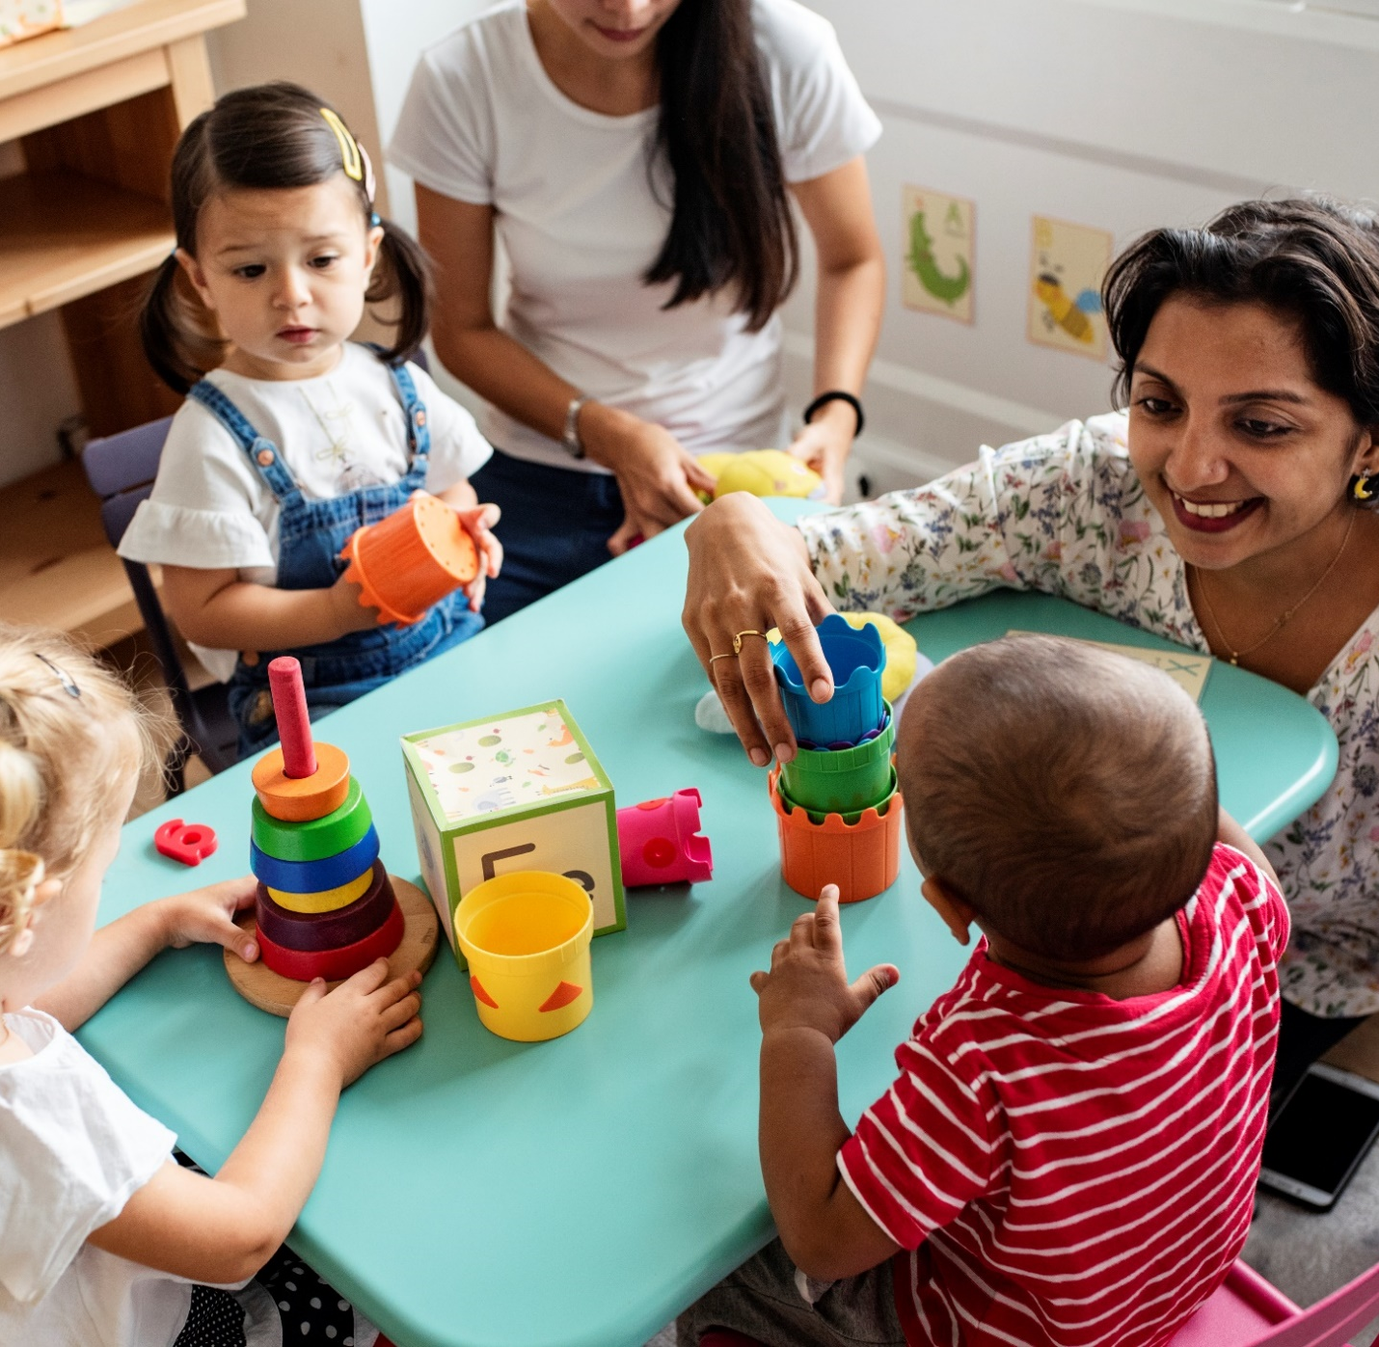

Unit 9 learning objectives
LO1 | Understand theories of play and its fundamental role in learning and development.
LO2 | Understand the significance of play for learning and development.
LO3 | Understand play at different stages of babies’ and children’s development.
LO4 | Understand different types of play for all children.
LO5 | Understand inclusive play practice.
LO6 | Be able to plan, lead and evaluate play opportunities in an early years setting.
LO7 | Be able to lead and support inclusive play experiences.
LO8 | Be able to apply theoretical perspectives and philosophical approaches in planning play opportunities.

Activity 1: right to play
Research and summarise the rights of children in relation to play, as detailed in the ‘United Nations Convention on the Rights of the Child’.

Activity 2: theories and philosophical approaches
Research and summarise different theories and philosophical approaches around play for babies’ and children's development.
Froebel | Stuart Lester
McMillan | Montessori
Wendy Russell | Steiner

Activity 3: significance of play for learning
Play is a significant tool for children’s learning and development.
Provide an example of how play can influence holistic development (social, emotional, physical, language, cognitive and mental wellbeing) and learning in children.

Activity 4: types of play
Research and summarise different types of play that support the stages of development, needs and interests of babies and children.
You should consider the theories of:
- Tina Bruce
- Bob Hughes
Use your research to plan a play session that includes a balance of child-centred and adult-led experiences.

Unit 10

Partnership working



Unit 10 learning objectives
LO1 | Understand the importance of developing and maintaining good relationships and partnerships in an early years setting.
LO2 | Understand the significance of parent and carer engagement.
LO3 | Understand how to build and sustain relationships with all parents and carers.
LO4 | Understand the importance of professional relationships with colleagues, other organisations, and agencies in working with and supporting early years settings and children.
LO5 | Understand that setting leaders need to collaborate and work with colleagues and other relevant professionals within and beyond their setting to ensure babies and children progress well in their learning.
LO6 | Understand that it is important to be an advocate for babies and children.
LO7 | Understand that Ofsted is responsible for the regulation and inspection of early years provision.
LO8 | Be able to work in partnership with parents and carers to help them recognise and value the significant contributions they make to the child’s health, wellbeing, and learning and development.
LO9 | Be able to encourage parents and carers to take an active role in their baby’s or child’s care, play, learning and development.
LO10 | Be able to explain the roles and responsibilities of other agencies and professionals that work with and support the setting and children, both statutory and non-statutory, and be familiar with statutory and non-statutory guidance to support this.
LO11 | Be able to work co-operatively and communicate effectively with key persons, colleagues, other professionals, and agencies to meet the needs of babies and children and enable them to progress.
LO12 | Be able to make additional provisions to support babies’ and children’s education and development where they lack this support from parents and carers.
LO13 | Be able to work confidently with the Ofsted early years inspection framework.
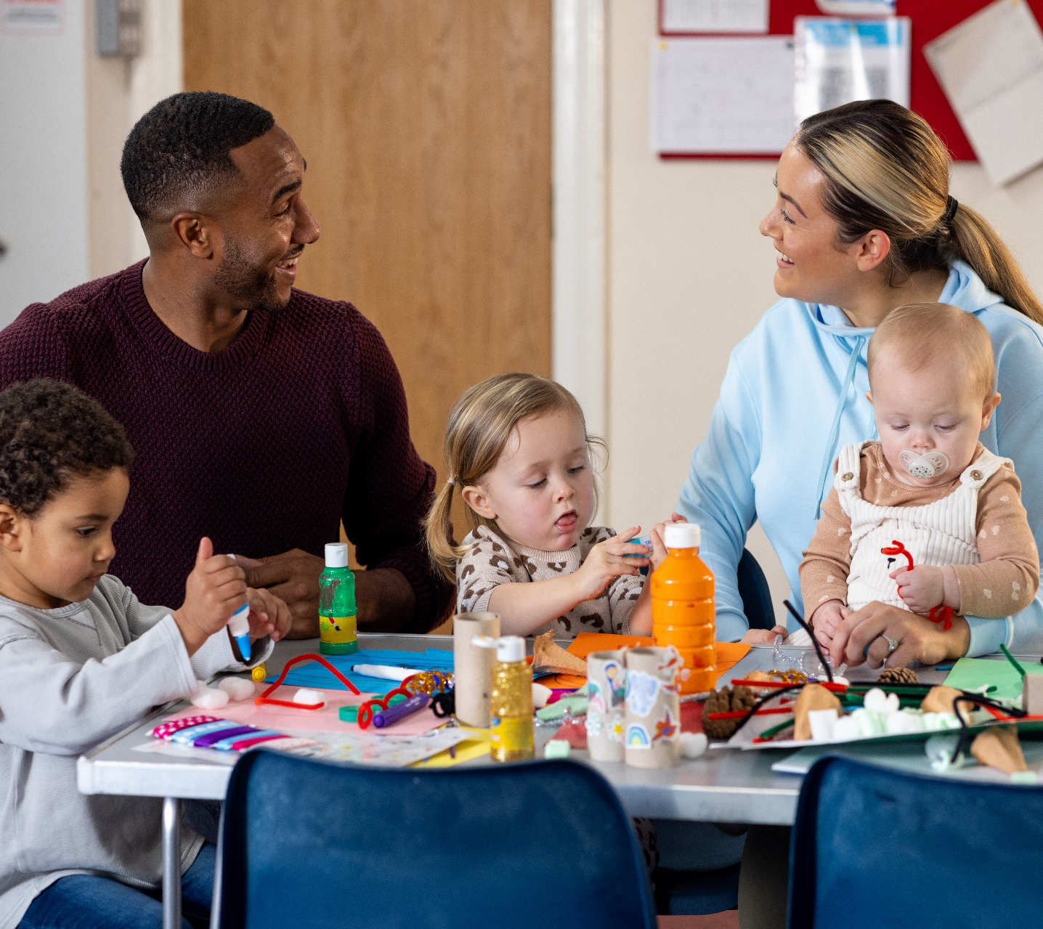

Activity 1: good relationships
Why is it important to develop and maintain positive relationships and partnerships in an early years setting? You should consider parents and carers as well as other agencies, organisations and professionals working in an early years setting.
How do these positive relationships and partnerships benefit the needs of babies and children?

Activity 2: engagement challenges
It is important for an early years educator to engage effectively with parents and carers within an early years setting.
List potential challenges to engagement with parents and carers and propose a solution to overcome them.
Challenge | Solution

Activity 3: role model
Explain why an early years educator should be an honest and respectful role model who can advocate for the interests, needs and wellbeing of babies and children.
You should consider how an early years educator might need to advocate for:
- a high-quality early years environment
- development need
- parent and carer engagement
- the home learning environment
- transition, including micro transitions and significant events

Activity 4: Ofsted
Review Ofsted’s early years inspection framework and summarise Ofsted’s regulatory role and responsibilities for an early years setting.

Activity 5: actively engage parents and carers
Describe an activity that could encourage parents and carers to take an active role in the care, play, learning and development of their baby or child.
If there is a lack of engagement from parents and carers, what additional provisions could an early years educator offer to support the education and development of the baby or child?

Workplace diary




Workplace diary
Use this diary to record the hours completed, reflect on what you have learnt, detail your successes and achievements and anything you would do differently next time.
Activity:
Date/time/hours: | Tutor signature:
Reflective notes:
Activity:
Date/time/hours: | Tutor signature:
Reflective notes:
Activity:
Date/time/hours: | Tutor signature:
Reflective notes:

Workplace diary
Use this diary to record the hours completed, reflect on what you have learnt, detail your successes and achievements and anything you would do differently next time.
Activity:
Date/time/hours: | Tutor signature:
Reflective notes:
Activity:
Date/time/hours: | Tutor signature:
Reflective notes:
Activity:
Date/time/hours: | Tutor signature:
Reflective notes:

Workplace diary
Use this diary to record the hours completed, reflect on what you have learnt, detail your successes and achievements and anything you would do differently next time.
Activity:
Date/time/hours: | Tutor signature:
Reflective notes:
Activity:
Date/time/hours: | Tutor signature:
Reflective notes:
Activity:
Date/time/hours: | Tutor signature:
Reflective notes:

Feedback and reflection



Feedback and reflection
Feedback is an excellent way to develop your skills and learn new ones. Obtain feedback from a colleague, a fellow learner or a tutor.
Reflect on your learning experience. Consider:
- what went well
- what did not go so well

Feedback and reflection
Feedback is an excellent way to develop your skills and learn new ones. Obtain feedback from a colleague, a fellow learner or a tutor.
Reflect on your learning experience. Consider:
- what went well
- what did not go so well

Feedback and reflection
Feedback is an excellent way to develop your skills and learn new ones. Obtain feedback from a colleague, a fellow learner or a tutor.
Reflect on your learning experience. Consider:
- what went well
- what did not go so well

Contact us
NCFE
Q6
Quorum Park
Benton Lane
Newcastle upon Tyne
NE12 8BT
0191 239 8000*
www.ncfe.org.uk
*to continue to improve our levels of customer service, telephone calls may be recorded for training and quality purposes.
NCFE is a registered charity (Registered Charity No. 1034808) and a company limited by guarantee (Company No. 2896700).

