**Guidance on**

**Preparing for Placement in Health and Social Care Settings**

**Module 2**

Contents

Hello and welcome back! 3

Topic 6: Exploring legislation, policy and procedure 3

Topic 7: Impact of COVID-19 on health and social care settings 7

Take away 9

**Hello and welcome back!**



“Hopefully you are starting to build a plan in relation to how you can prepare for your placement. In this module we will be looking at legislation, policies and procedures which inform practice. It’s a tough area however you will be able to apply your learning to your placement once started. We will also consider the impact of Covid-19 on health and social care settings.”

**Topic 6: Exploring legislation, policy and procedure**

When you begin your placement it will be helpful if you have already explored legislation, policies and procedures relevant to your role as a health and social care practitioner. In this section we will guide you to legislation that you will need to have an awareness of.

Legislation defines responsibilities and accountabilities that must be adhered to in relation to keeping everyone safe, healthy and well. Legislation is often accompanied by supporting guidance.

The main legislation you will explore throughout your course will relate to:

* health and safety
* equality and diversity
* safeguarding and protection.

Try to identify the name of specific legislation and/or guidance for the 3 areas identified above. Now research policies and procedures that health and social care settings follow in order to uphold the legislation identified. Linking to policies and procedures will support you to make sense of how legislation informs practice when working with individuals.

To help you, you can view NHS policies and procedures here: [www.england.nhs.uk/contact-us/pub-scheme/pol-proc/](http://www.england.nhs.uk/contact-us/pub-scheme/pol-proc/). Alternatively you could search your Local Authority’s website to access their policies and procedures relevant to care services.

Complete the table below. Structure your research by:

* summarising the main points of the legislation
* identifying a workplace policy or procedure which is informed by the legislation
* identifying the responsibilities of the health and social care practitioner as defined by the policy or procedure.

|  |  |  |  |
| --- | --- | --- | --- |
|  | **Health and safety** | **Equality and diversity** | **Safeguarding and protection** |
| Legislation |  |  |  |
| Policy or procedure |  |  |  |
| Responsibilities |  |  |  |

When you start placement if you are unsure about any policies or procedures, always make sure you check with a member of staff. This is really important.



“Not an easy area to understand but you will follow legislation simply through engaging in the daily routines in the setting, all of which will be arranged around policies and procedures. As stated, learning in relation to legislation will help you once you are in your placement. It will also help you with your course work.”



“So now you have explored legislation, policies and procedures. This is a big topic area with lots of information to absorb, how did you do? Do you feel more confident that you will have a better understanding for when you go into your placement?”



“All of the knowledge you have gained so far will help you so much therefore keep going! If you signed up to CACHE Alumni take time now to use your membership to explore the range of health and social care resources available, many of these link to legislation.”

**Activity**

Did you find a particular article of interest? Summarise your learning.

**Topic 7: Impact of COVID-19 on health and social care settings**

Due to COVID-19 the world is a different place and we all have to learn how to live in the new normal. This means that when you do go into placement you will need to take precautions to protect yourself, your colleagues and of course the individuals that you will be supporting.

You may find it helpful to watch this short clip which gives an overview of COVID-19:

[www.youtube.com/watch?v=1APwq1df6Mw&feature=emb_logo](http://www.youtube.com/watch?v=1APwq1df6Mw&feature=emb_logo)

Of course infection prevention and control is key to practice in all health and social care settings. Do you know the correct handwashing technique? Watch this video to be sure: [www.youtu.be/bQCP7waTRWU](https://youtu.be/bQCP7waTRWU)

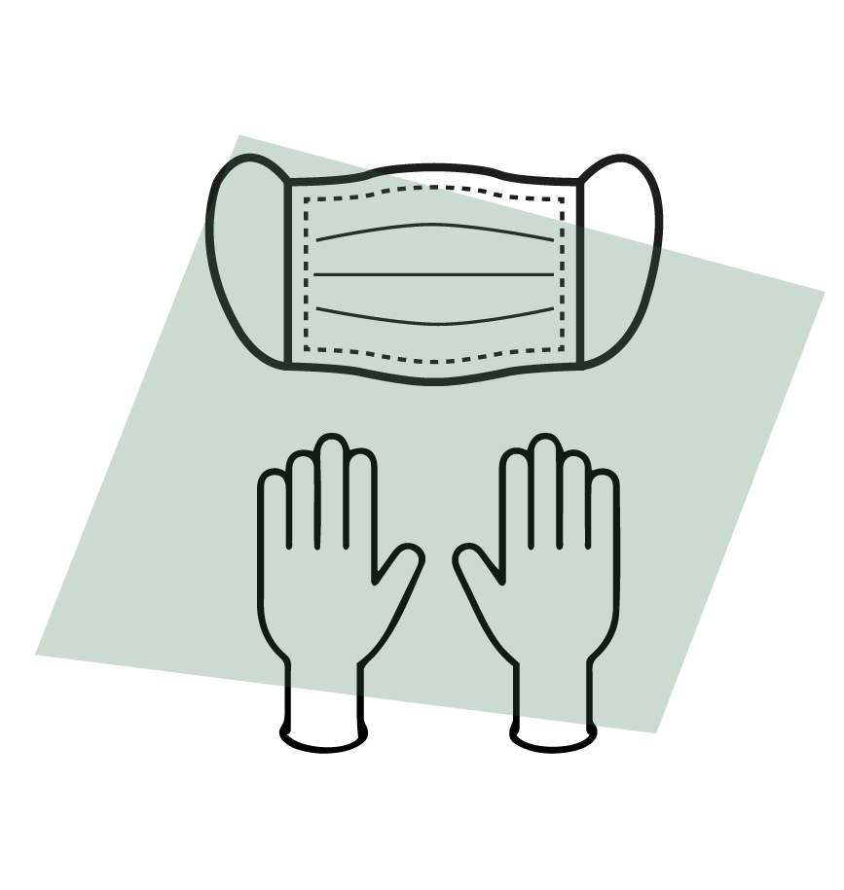

Why is Personal Protective Equipment (PPE) important?

PPE manages the risk of infection spreading. The need for PPE will be identified through a risk assessment that has been undertaken by a competent person.

Of course health and social care practitioners need to wear PPE when undertaking a variety of tasks such as supporting with personal care, managing waste and so forth.

Read this quick guide from NICE which provides a useful overview of how to prevent infection: [www.nice.org.uk/about/nice-communities/social-care/quick-guides/helping-to-prevent-infection](http://www.nice.org.uk/about/nice-communities/social-care/quick-guides/helping-to-prevent-infection)

When using PPE, it is important to follow the correct donning (putting on) and doffing (taking off) procedures. This video demonstrates the correct donning and doffing procedures in relation to COVID-19 for health and social care practitioners: [www.youtu.be/-GncQ_ed-9w](https://youtu.be/-GncQ_ed-9w)

Now see if you can answer the following questions:

* Transmission of coronavirus (COVID-19) mainly occurs via?
* In settings managing the spread of coronavirus (COVID-19) involves?
* Describe the correct hand washing technique.

There are a wealth of resources available in relation to COVID-19 from the government, NHS and Sector Skills Councils. If you would like to find out more you can view these here:

[www.gov.uk/coronavirus](http://www.gov.uk/coronavirus)

[www.skillsforcare.org.uk/Home.aspx?gclid=EAIaIQobChMIpN-IitbM6gIVg-3tCh1sbAJEEAAYASAAEgLE4fD_BwE](http://www.skillsforcare.org.uk/Home.aspx?gclid=EAIaIQobChMIpN-IitbM6gIVg-3tCh1sbAJEEAAYASAAEgLE4fD_BwE)

[www.skillsforhealth.org.uk/covid-19-coronavirus-info?highlight=WyJjb3ZpZCIsMTksIjE5JyIsImNvdmlkIDE5Il0=](http://www.skillsforhealth.org.uk/covid-19-coronavirus-info?highlight=WyJjb3ZpZCIsMTksIjE5JyIsImNvdmlkIDE5Il0=)

## **Take away**

To conclude the 6 points below should be actioned not only when in placement but wherever you have contact with others. Keep safe!



“You are progressing through the programme really well! So far the focus has been on things you need to do or think about before you begin your placement. This will ensure that you get off to a great start.

In the next module you will begin to explore professional development, progression opportunities and career pathways available to you.”